 Province of the

EASTERN CAPE

EDUCATION

**DIRECTORATE SENIOR CURRICULUM MANAGEMENT (SEN-FET)**

**HOME SCHOOLING SELF-STUDY WORKSHEET**

|  |  |  |  |  |  |
| --- | --- | --- | --- | --- | --- |
| **SUBJECT** | FITTING & MACHINING | **GRADE** |  | **DATE** | APRIL 2020  WEEK 3 |
| **TOPIC** | MOMENTS TEST | **TERM 1**  **REVISION** | (Please tick) | **TERM 2 CONTENT** | (√) |
| **TIME ALLOCATION** | 2H30 | **TIPS TO KEEP HEALTHY**  1. **WASH YOUR HANDS** thoroughly with soap and water for at least 20 seconds. Alternatively, use hand sanitizer with an alcohol content of at least 60%.  2. **PRACTICE SOCIAL DISTANCING** – keep a distance of 1m away from other people.  3. **PRACTISE GOOD RESPIRATORY HYGIENE**: cough or sneeze into your elbow or tissue and dispose of the tissue immediately after use.  4. **TRY NOT TO TOUCH YOUR FACE.** The virus can be transferred from your hands to your nose, mouth and eyes. It can then enter your body and make you sick.  5. **STAY AT HOME.** | | | |
| **INSTRUCTIONS** | ANWER ALL QUESTIONS |

**Question 1**

The diagram below shows a beam with two vertical point loads of 2 800 N and 700 N acting on it. The beam is supported at point **O**.

Calculate distance **X** from **O** to place the 700 N load to ensure that the beam is in equilibrium.

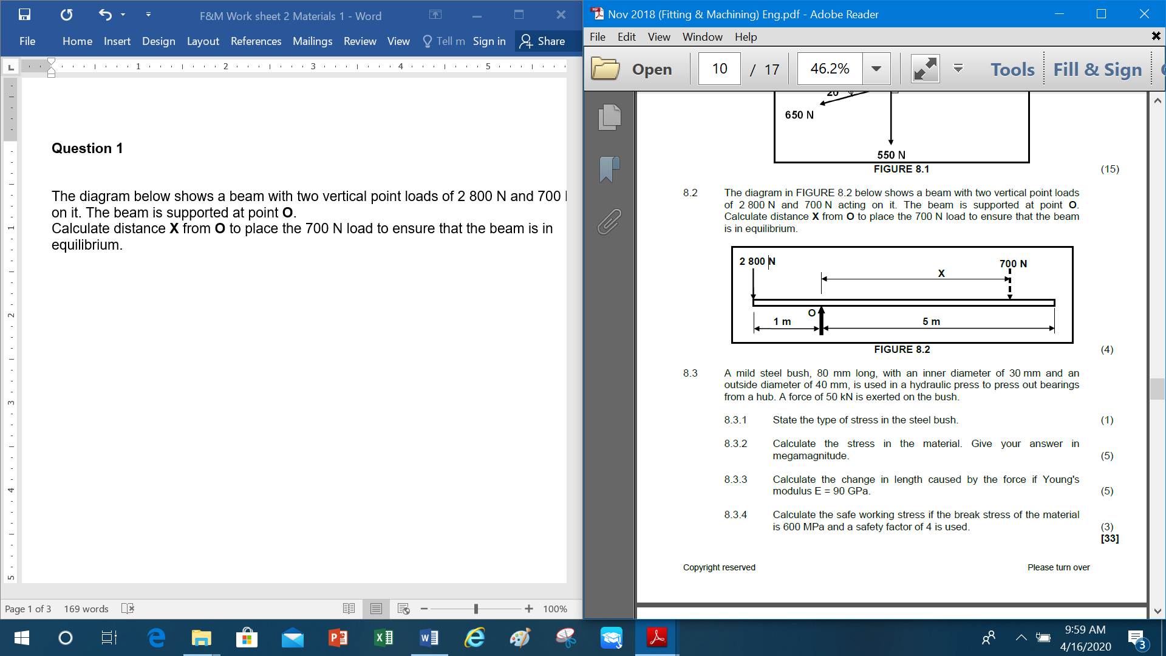

**Question 2**

A lever is 6 m long and its fulcrum is 1.5 m away from the left end of the lever. A force of 250 N acts downwards on the left end. It also carries two other concentrated loads, one being 60 N and 3,5 m from the left end and the other being 80 N.

Calculate the distance from the left end to the concentrated load of 80 N which will ensure that the lever is in equilibrium.



**Question 3**

The diagram below shows a 4 m long beam supported by two vertical supports, **A** and **B**. Two vertical point loads of 800 N, 300 N and a uniformly distributed load of 180 N/m is exerted over the left half of the beam. Calculate the magnitude of the reactions in supports **A** and **B**. **(Draw and complete the diagram below and indicate the point load that replaces the uniformly distributed load.)**

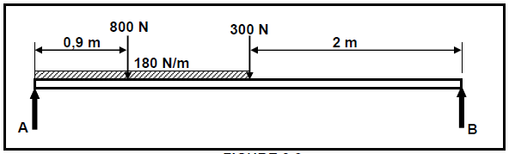

**Question 4**

The diagram below shows a beam supported by two vertical supports, A and B.

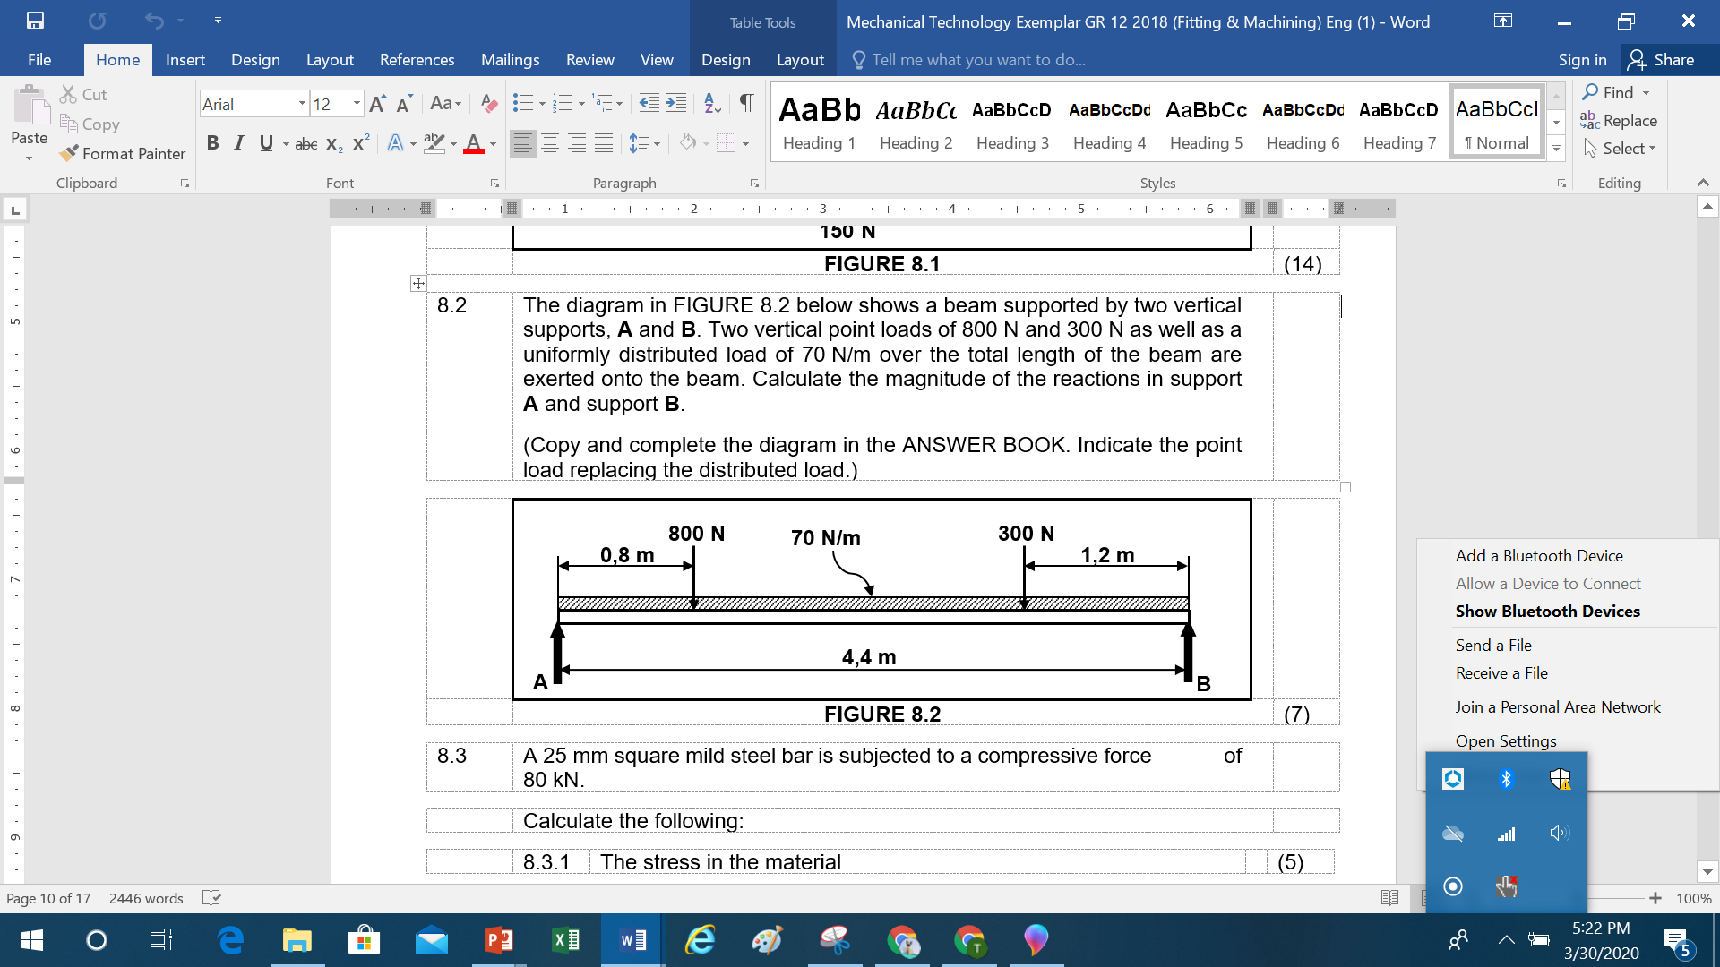

Calculate:

a) Draw and complete the diagram and indicate the point load that replaces the distributed load.

b) The magnitude of the reactions in supports A and B.