DIRECTORATE SENIOR CURRICULUM MANAGEMENT (SEN-FET)
HOME SCHOOLING SELF-STUDY WORKSHEET
SUBJECT | Nautical Science | GRADE | 10 | DATE | 7/4/20
TOPIC | Nautical terminology/Ship Parts/ Relative Positions/ Command and Control | TERM 1  REVISION |  | TERM 2 CONTENT | X
TIME ALLOCATION | 20min | TIPS TO KEEP HEALTHY  1. WASH YOUR HANDS thoroughly with soap and water for at least 20 seconds. Alternatively, use hand sanitizer with an alcohol content of at least 60%.  2. PRACTICE SOCIAL DISTANCING – keep a distance of 1m away from other people.  3. PRACTISE GOOD RESPIRATORY HYGIENE: cough or sneeze into your elbow or tissue and dispose of the tissue immediately after use.  4. TRY NOT TO TOUCH YOUR FACE. The virus can be transferred from your hands to your nose, mouth and eyes. It can then enter your body and make you sick.  5. STAY AT HOME.
INSTRUCTIONS | This worksheet is to be completed in your MRTE exercise/activity book.
Question 6
6.1 From the terms provided in the table below identify the most appropriate term defined by the following statement:
a. The vertical distance between the water line and weather deck of a vessel. (1)
b. The widest width/breadth of a ship. (1)
c. A propulsion unit that gives transverse motion to a ship. (1)
d. A propulsion unit that gives ahead and astern motion to a ship. (1)
e. A ______ enables the vessel to maintain her course. (1)
Hull Freeboard Bulbous bow Bottom Rudder
Beam Bow thruster Propeller Draught (draft) Radar
[5]
QUESTION 7
7.1 Give the seaman terms that describe the various positions / points of orientation around a ship. (8)
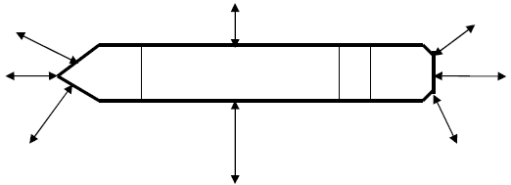
f
a
b
c
g
h
d
e

QUESTION 8
8.1. After lengthy periods on the high seas, on reaching coastal waters of South Africa, the captain of a vessel charted (hired) a boat or helicopter to deliver him to the nearest casino in order to satisfy his gambling cravings. He delegated command of the vessel to his second-in-charge, the Chief Officer, for the duration of his absence.

a. In regard to ‘command’, are the Captain’s action permitted? (1)
b. Justify your answer to the above question. (2)

8.2 When/if the Captain and Chief Officer of a ship are disabled, the next senior officers onboard are the Chief Engineer and Second Mate.

- Who assumes (take over) the command responsibilities for the
vessel? (1)
b. Give motivation for your reply to the above question. (2)

