Province of the
EASTERN CAPE
EDUCATION

Steve Vukile Tshwete Education Complex • Zone 6 Zwelitsha 5608 • Private Bag X0032 • Bhisho 5605
REPUBLIC OF SOUTH AFRICA

CHIEF DIRECTORATE – CURRICULUM MANAGEMENT

INKQUBO YOKUNCEDISA ABAFUNDI BEBANGA LE-12

ISIXHOBO SOKUFUNDA ESILUNGISELELWE UHLAZIYO NOKUNCEDISA:
IMIBUZO NEEMPENDULO

ISIFUNDO: ISIXHOSA ULWIMI LWASEKHAYA – ISIGABA SESITHATHU

EYESILIMELA 2009
ESI SIXHOBO SINAMAPHEPHA ASI-8.

ESI SIXHOBO MASINGASETYENZISWA NJENGOVIWO

IMIYALELO EYA KUBAFUNDI

1. | Umviwa kulindeleke ukuba aphendule umbuzo OMNYE kwiCandelo ngalinye.
2. | Icandelo ngalinye malibhalwe kwiphepha elitsha, uze ukrwele umgca wakugqiba iCandelo elo.
3. | Bhala cacileyo nacocekileyo, ucwangcise kakuhle umsebenzi wakho.
4. | Nika ingqalelo eyodwa kupelo lwamagama kunye nolwakhiwo lwezivakalisi.
5. | UBUDE BEEMPENDULO:
ICANDELO A: ISINCOKO:
- Bhala isincoko esingama-340 ─ 390 amagama (Amaphepha amabini ukuya kwamabini anesiqingatha).
ICANDELO B: IMIHLATHANA EMIDE:
- Bhala amagama ali-100 ─ 120 amagama (Iphepha elinye ukuya kwelinye elinesiqingatha).
ICANDELO C: IMIHLATHANA EMIFUTSHANE:
- Bhala ama-80 ─100 amagama (Iphepha elinye kuphela).

ICANDELO A: IZINCOKO
UMBUZO 1
Apha ngasezantsi udweliselwe izihloko ezahlukeneyo. Zifunde zonke uze emva koko ukhethe sibe siNYE osithandayo, ubhale isincoko esibude bungama-340 ukuya ku-390 amagama. (Amaphepha amabini ukuya kwamabini anesiqingatha)
1.1 | “Kubo-o-omvu!” Le yintsholo eyenziwa ngumhlobo wakho emi emnyango, ngaphakathi endlwini ziyaduma, izitulo zithe nca emacaleni, kuqhaqhazela iifestile ngumculo. Balisa ngomhla enabhaqwa ngawo nabahlobo bakho ngabazali beningalindele. |  |  | [50]
 | OKANYE
1.2 | Imali iluncedo, kodwa ikwayiyo nengcambu yesono. Bhala isincoko uwavelele omabini la macala, uxoxe kuvokotheke. |  |  | [50]
 | OKANYE
1.3 | Le tshati ingezantsi ibonisa indlela uMphathiswa wezeMali awabele ngayo amaSebe ukuphuhlisa intlalo yoluntu. Uyavumelana nale ndlela abelwe ngayo amaSebe? Bhala isincoko apho unika khona iimbono zakho. |  |  | [50]
 | 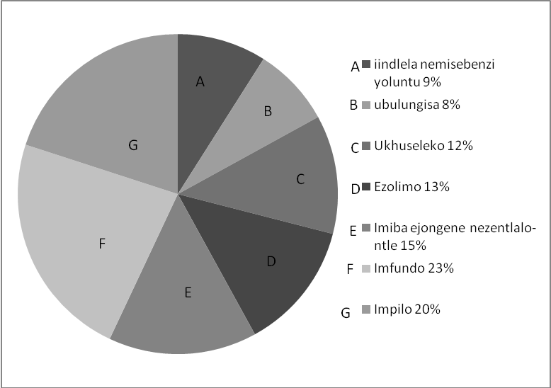

OKANYE

1.4 | Inani lamatyotyombe liya lisanda ngokwanda kwiidolophu zoMzantsi Afrika nangona uRhulumente ezama. Ucinga ukuba kungenziwa njani ukuphucula le meko? | [50]
 | OKANYE
1.5 | Bhala isincoko apho uza kudandalazisa izicwangciso namaphupha akho  ngekamva lakho emva kokuphumelela ibanga leMatriki. | [50]
 | OKANYE
1.6 | Uthando olululo | [50]
 | OKANYE
1.7 | Imifanekiso iyathetha. Xa ujonge lo ungezantsi unavakalelo luni? Ziyilele isihloko sakho ubhale isincoko esiva wena. | [50]
 | 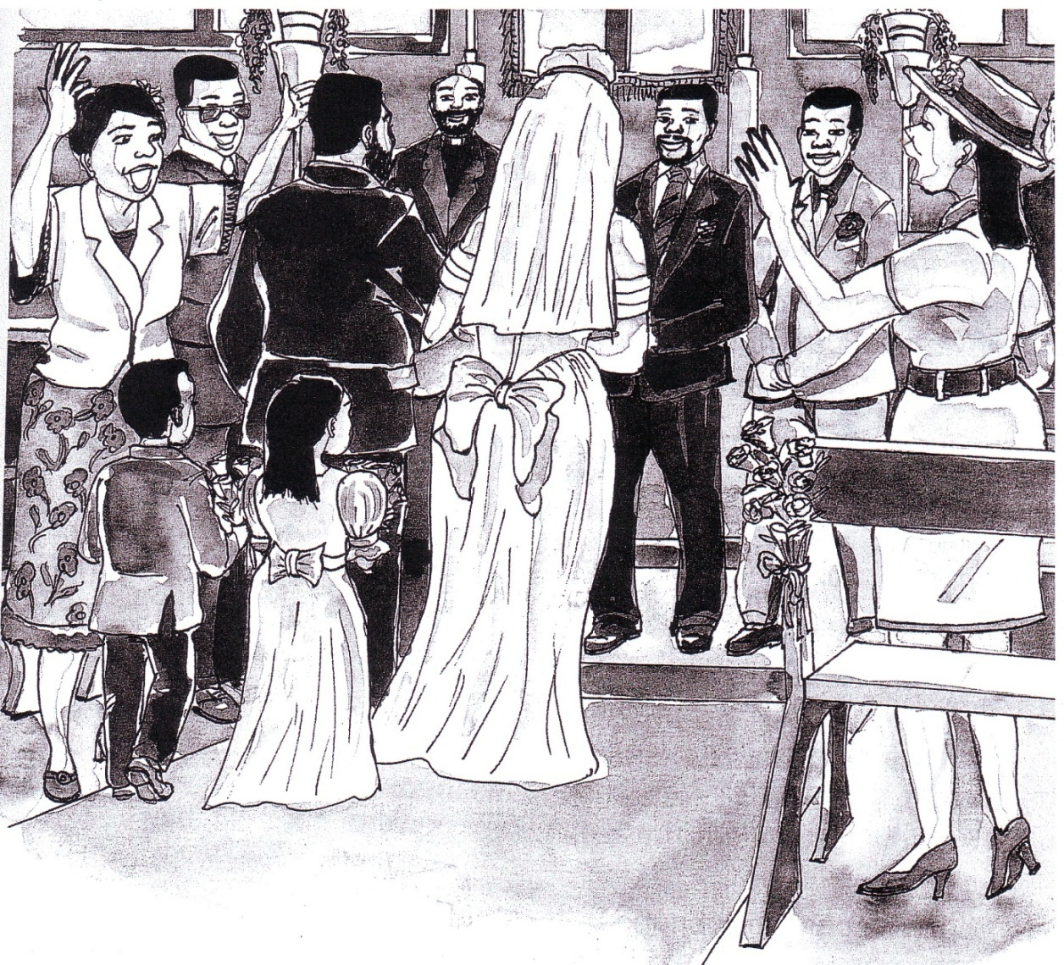
 | [Ithatyathwe : Simnandi IsiXhosa Iphepha 119]
OKANYE

1.8 | Qwalasela lo mfanekiso, uze ubhale isincoko ngesaci okanye iqhalo olenze ngawo.

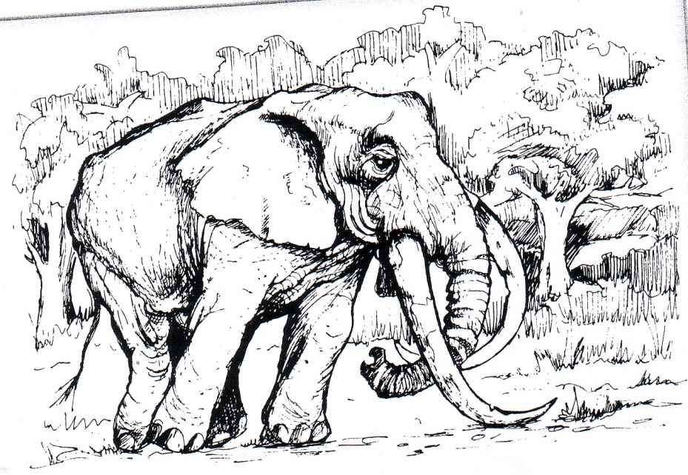
Ithathwe: Dynamic English Iphepha 64

 | EWONKE AMANQAKU ECANDELO A: | 50

ICANDELO B: IMIHLATHANA EMIDE
UMBUZO 2
Khetha umhlathana omde ube MNYE kule ilapha ngezantsi ubhale ngawo. Ubude mabube ngamagama ali-100 ukuya kuma-120. (Iphepha elinye ukuya kwelinye elinesiqingatha)
2.1 | ILETA YOMCIMBI
 | Uthenge unomathotholo odlala amacwecwe kunye nomabonakude kumzi wakwaShake`s Radio, TV Shops, 42 Dusha Road, Mgagasi, 4001, kwiiveki ezimbini ezidlulileyo. Kungoku nje unomathotholo akadlali, umabonakude uyarharhaza ayiveli imifanekiso. Bhalela umnini venkile ileta ukhalaza. | [30]
 | OKANYE
2.2 | IMEMORANDAM
 | UnguManejala weSuphamakethi enkulu, uqaphele ukuba abasebenzi ababaphathi kakuhle abathengi. Bhala imemorandam apho unika khona imiyalelo emayilandelwe khon`ukuze batshintshe indlela abazijonga ngayo izinto. | [30]
 | OKANYE
2.3 | INGXOXO YABABINI
 | Ufika iingxoxo ishushu phakathi kwezi nzwakazi.  Umba otshisa ibunzi ngulo: “Ingaba kulungile ukuba abazali babe nolwazi yaye babe nenxaxheba abayidlalayo kwimiba yothando kubantwana babo?” Bhala le ngxoxo, ubonise izimvo zomfundi ngamnye. | [30]
 | OKANYE

2.4 | I-OBHITSHWARI
 | Ngokwalo mfanekiso ulandelayo, namhlanje kungcwatywa ubawo uDilizingalo Kunene ebumelwaneni, nongutata weli khaya. Uceliwe ukuba uncedise kumalungiselelo omngcwabo ngokuthi ubhale ngentyila-bomi ngomfi (obhitshuwari) njengoko uxelelwe yonke imbali ngaye lolu sapho.
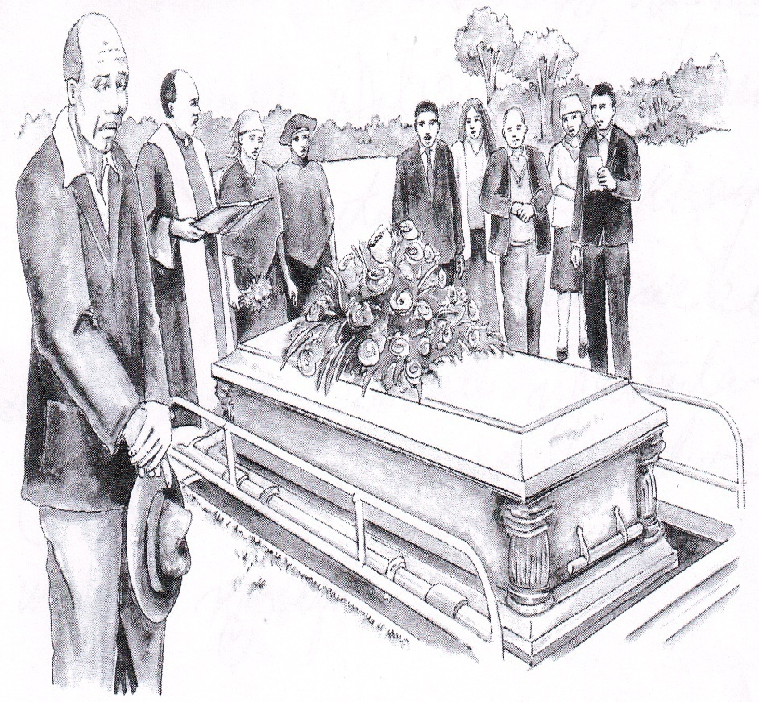
Ithathwe: Yonwabela IsiXhosa Iphepha 54
 |  | [30]
 | EWONKE AMANQAKU ECANDELO B: | 30

ICANDELO C: IMIHLATHANA EMIFUTSHANE
UMBUZO 3
Bhala umhlathana ube MNYE kweli Candelo: Ubude bawo mabube ngamagama
angama-80 ukuya kwali-100.(Iphepha elinye kuphela).
3.1 | ISIBHENGEZO SOMSEBENZI
 | Umzi wakwaKentucky unezithuba zomsebenzi ofuna abantu abane, abaza kuncedisa ekuthengiseleni. Bhala isibhengezo, unike iinkcukacha ezilindelekileyo kulowo ufake isicelo, indlela yokunxibelelana nalo mzi kwanosuku lokuvala. | [20]
 | OKANYE
3.2 | IKHADI LESIMEMO
 | Abazali bakho bagqiba amashumi amabini eminyaka betshatile. Nilusapho nigqibe ekubeni nibenzele itheko lokubhiyozela le minyaka ngeeholide zePasika. Yila ikhadi lesimemo oza kulithumela kwizihlobo nezizalwane. Makubekho nelinye ikhadi eliphendulayo, lisenokuvuma okanye lilandule. | [20]
 | OKANYE
3.3 | IMIYALELO
 | Unomhlobo onengxaki yobunzima bomzimba obungalawulekiyo nobungahambelaniyo nobudala kunye nobude bakhe. Ixhala lakho lelokuba avelelwe sisifo soxinzelelo lwegazi, esentliziyo, eseswekile nezinye. Bhala imiyalelo apho umcebisa khona khon`ukuze asinde kwezi zifo, athobe nobunzima. Imiyalelo ingedluli kwiingongoma ezilishumi. | [20]
 | EWONKE AMANQAKU ECANDELO C: | 20
 | EWONKE AMANQAKU: | 100

