XHOSA

ISEBE LEMFUNDO LEMPUMA KOLONI
EASTERN CAPE EDUCATION DEPARTMENT
OOS-KAAP ONDERWYSDEPARTEMENT

IIMVIWO ZEBANGA LOKUGQIBELA
NATIONAL SENIOR CERTIFICATE EXAMINATION
NASIONALE SENIOR SERTIFIKAAT-EKSAMEN

JUNE EXEMPLAR 2009

ISIXHOSA ULWIMI OLONGEZELELWEYO – P1

XHOSA SECOND ADDITIONAL LANGUAGE – P1

IXESHA: 2 iiyure TIME: 2 hours TYD: 2 uur
AMANQAKU: 120 MARKS: 120 PUNTE: 120

Write on the cover of your answer book, after the word “Subject” –

XHOSA SECOND ADDITIONAL LANGUAGE - PAPER 1

Olu viwo lunamaphepha ali - 14.

IMIYALELO

1. | Eli phepha lemibuzo linamacandelo AMANE angala:  * ICANDELO A Uvavanyo lokuqonda (30)  * ICANDELO B Ushwankathelo (10)  * ICANDELO C Ukusetyenziswa kolwimi (60)  * ICANDELO D Uncwadi (20)
2. | Phendula YONKE imibuzo
3. | Bhala icandelo ngalinye kwiphepha ELITSHA uze ukrwele umgca  ekupheleni kwecandelo.
4. | Shiya umgca emva kwempendulo NGANYE.
5. | Bhala ngokucocekileyo nangokucacileyo.
6. | Bhala iimpendulo zakho ngokuchanekileyo ngokwendlela yokunombola esetyenzisiweyo kwiphepha lemibuzo.
7. | Qwalasela upelo nolwakhiwo lwezivakalisi.

ICANDELO A : UVAVANYO LOKUQONDA
UMBUZO 1

ISICATSHULWA A

UMABONAKUDE NEVIDIYO

Yonke imifanekiso nezandi ozonwabelayo kumabonakude zihambe zeza kufika kuyo ngomoya. Zihamba oku kwamaza onomathotholo. Amaza kanomathotholo luthotho lwemiqondiso ethunyelwa ngomoya. Le miqondiso icholwacholwa ieriyali yomabonakude. La maza onomathotholo avela kumazwe ngamazwe.

Le ndlela amaza onomthotholo athunyelwa ngayo kuthiwa kukusasaza. Unakho ukubukela usasazo kumabonakude ngexesha elinye kunye nabahlobo bakho. Ukuba ngaba kukho iindaba ezibalulekileyo okanye umdlalo obalulekileyo, abantu kwilizwe lonke banakho ukubukela ngeli xesha wenzeka ngalo.

Unakho ukubona abantu abaninzi obaziyo kumabonakude, kodwa kukho abanye abaninzi abasebenza kwakumabonakude ababuso babo ungasokuze ububone.

Yonke imifanekiso esiyibona kumabonakude yenziwe ngekhamera kamabonakude. Iyenza le nto ngokucholachola amaza okukhanya. La maza enziwa yimibala yento nganye efotwayo. Okunye ukukhanya okuwela kwezi zinto zifotwayo kuyacholwacholwa yinto leyo. Okunye ukukhanya kubuyiselwa umva. Koku kukhanya kwamaza kubuyiselwa mva oku kubangela imibala esiyibonayo kumabonakude.

La maza anokukhanya okubuyiselwe umva ungawahlula abe yimibala emithathu. Le mibala yile: ngobomvu, ngozuba kunye noluhlaza. Le mibala yimibala engavelanga ngokuxutywa kwemibala emibini.

Yonke eminye imibala oyibona kumabonakude yenziwe ngokudityaniswa imibala kunye nobomvu okanye ozuba okanye oluhlaza. Xa udibanisa ngokulinganayo le mibala mithathu ufumana umbala omhlophe.

IMIBUZO

1.1
 | 1.1.1 | Le mifanekiso ihamba njani ukuza kufika kumabonakude? | (2)
 | 1.1.2 | Yiyiphi imibala esetyenziswayo kumabonakude? | (2)
 | 1.1.3 | Indlela athunyelwa ngayo la maza sithi … | (2)
 | 1.1.4 | La maza acholacholwa yi … | (2)
 | 1.1.5 | Ingaba uthanda ukubukela umabonakude okanye ukumamela unothotholo? | (4)
 | 1.1.6 | Xa kutyaniswe umbala ozuba, oluhlaza kunye nobomvu, kuphuma wuphi umbala? | (2)
 | 1.1.7 | Wena, xa ubukela umabonakude, uthanda ukubukela nabani? | (2)
1.8 |  | Yintoni uncedo lukamabonakude malunga neendaba? | (2)
1.9 |  | Iinkqubo zemidlalo zivela nini kumabonakude kwiSABC? | (2)
 | 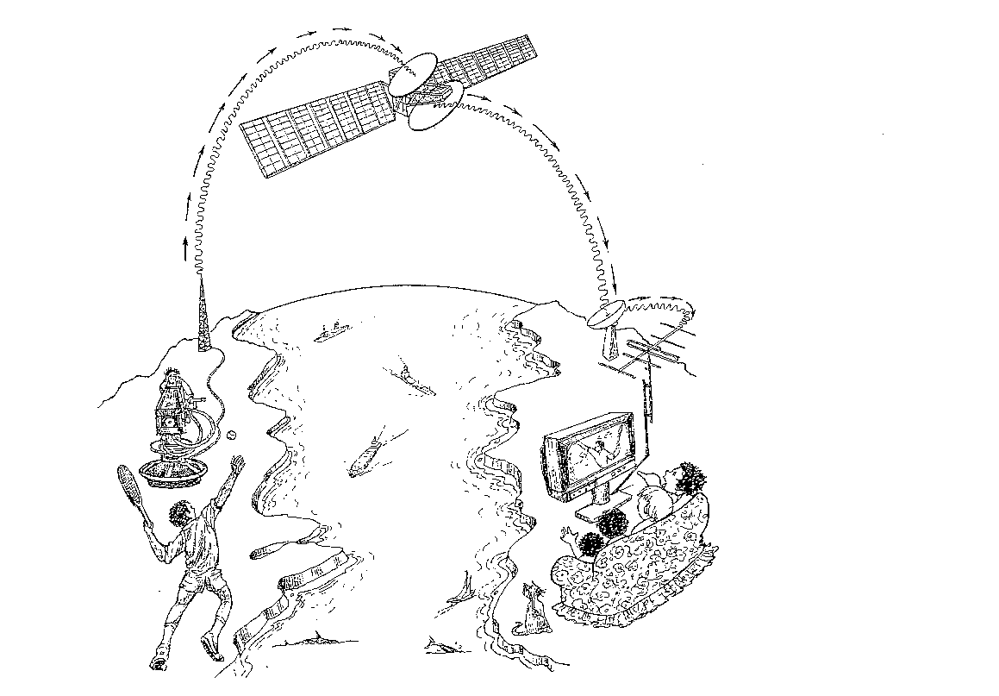 |  | (20)

ICANDELO : A
ISICATSHULWA B : OKUBONAYO
Jonga lo mfanekiso, uze uphendule le mibuzo ilandelayo.
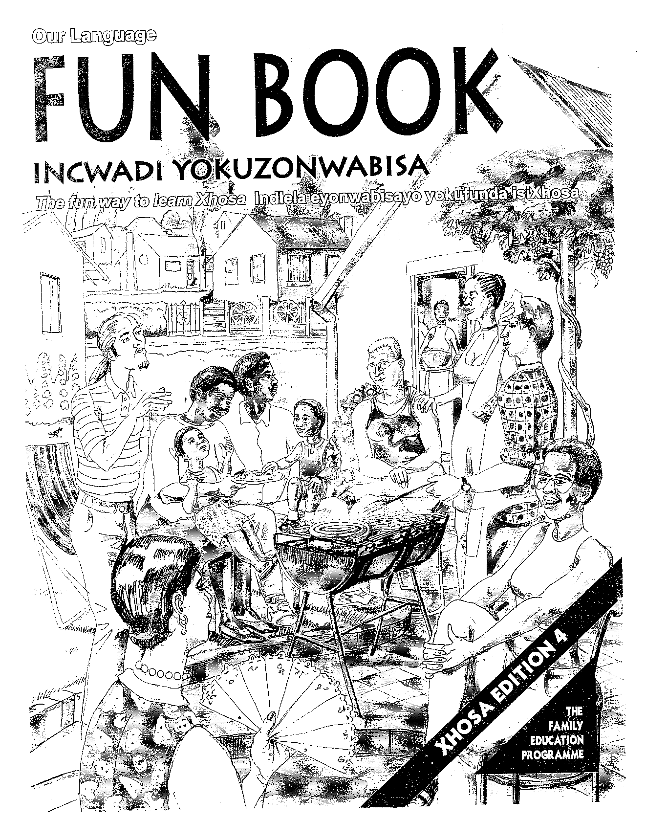
IMIBUZO
1.2
 | 1.2.1 | Ubuntu buyabonakala kulo mfanekiso? Kutheni usitsho nje? Nika izizathu ezimbini. |  | (2)
 | 1.2.2 | Aba bantu baziva njani? Ngokujonga kulo mfanekiso, nika izizathu ezimbini. |  | (2)
 | 1.2.3 | Ucinga ukuba leliphi ixesha lonyaka eli? Kubonakaliswe njani oku?  - Ilanga liyatshisa.  - Banxiba iimpahla ezipholileyo.  - Boja inyama. |  | (2)
 | 1.2.4 | Kubonakala ukuba aba bantu abaswelanga nto. Kutheni  kusitshiwo nje? |  | (4)
 | AMANQAKU ECANDELO A: 30

ICANDELO B : ISISHWANKATHELO
UMBUZO 2
2.1 | Funda esi sicatshulwa silandelayo sihamba nemifanekiso uze usishwankathele.
 | 2.1.1 | Shwankathela esi sicatshulwa uthethe ngezi zinto:
 |  | - Indima edlalwa lukhenketha njengeshishini.
 |  | - Uncedo lwabakhenkethi abatyelela elizweni lethu. | (7)
 | 2.2.2 | Bhala ngezivakalisi ezipheleleyo. Sebenzisa ulwimi olufanelekileyo. | (2)
 | 2.2.3 | Shwankathela ngamagama angama - 40 ukuya kuma - 50. Bhala inani lamagama ozakuwasebenzisa. | (1)
Iinguqu ezithe zakho kwezopolitiki eMzantsi Afrika
zenze ukuba ushishino lwezokhenketho luye lukhula ngokukhula. Njengoko ukhenkhentho ilishishini elixhomekeke kubasebenzi, ininzi into eza kuxhanyulwa ngabemi beli lizwe. Imali etyalwa ngabakhenkethi ivula amathuba emisebenzi. Kuqikelelwa ekubeni ngabakhenkethi abangamashumi amathathu kuvuleka amathuba omsebenzi abantu ababini. Loo nto ithetha ukuba nabasebenzi abathi baqeshwe kweli shishini bayanda yaye iindleko zokubaqeqesha azingako.

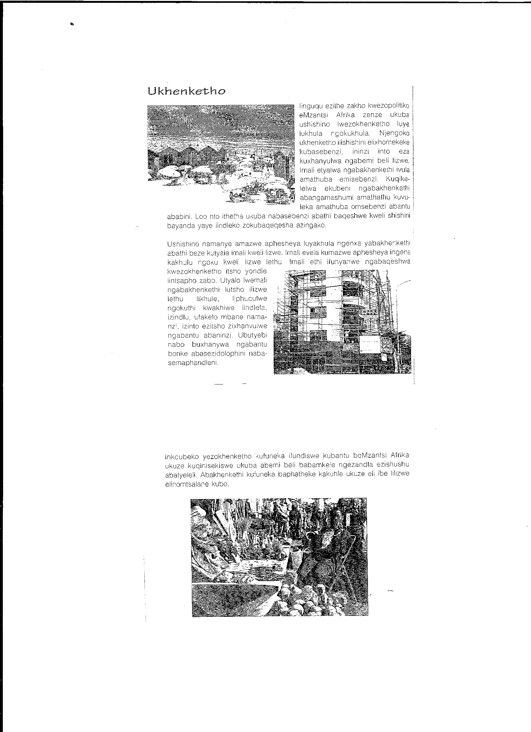

Ushishino namanye amazwe aphesheya luyakhula ngenxa
yabakhenkethi abathi beze kutyala imali kweli lizwe. Imali evela kumazwe aphesheya ingena kakhulu ngoku kweli lizwe. Imali ethi ifunyanwe ngabaqeshwa kwezokhenketho itsho yondle iintsapho zabo. Utyalo lwemali ngabakhenkethi lutsho ilizwe lethu likhule. Liphuculwe ngokuthi kwakhiwe iindlela, izindlu, ufakelo mbane nezinzi izinto ezitsho zixhanyulwe ngabantu abaninzi. Ubutyebi nabo buxhanyulwa ngabantu bonke abasedolophini nabasemaphandleni.

Inkcubeko yezokhenketho kufuneka ifundiswe kubantu boMzantsi Afrika ukuze kuqinisekiswe ukuba abemi beli babamkele ngezandla ezishushu abatyeleli. Abakhenkethi kufuneka baphatheke kakuhle ukuze eli libe lilizwe elinomtsalane kubo.

 |  | AMANQAKU ECANDELO B : 10

ICANDELO C : UKUSETYENZISWA KOLWIMI

UMBUZO 3
3.1 | Fakela izimamva ezifanelekileyo. Khetha kwezi. Bhala igama kuphela.
 | [ - eka , -isa , -wa ]
Umzekelo: Umhloli ufunda abafundi.
Impendulo: Umhloli ufundisa abafundi.
 | 3.1.1 | Ilizwe lityelela ngabakhenkethi. | (1)
 | 3.1.2 | Utitshala uyathanda kakhulu. | (1)
3.2 | Phinda ubhale esi sicatshulwa silandelayo uze ulungise iziphene nolwimi olungamkelekanga.
 |  | ngenye imini intombi wenkosi ethile waya kudlala ngasemlanjeni.iphethe ibhola eyenziwe igolide. Yadibana isele. Eli sele yafuna ukudlala ngentombi. | (7)
3.3 | Bhala igama elifanelekileyo kuphela elikwizibiyeli ( … )
 | 3.3.1 | Umphathi weMfundo (-fika) esikolweni. | (1)
 | 3.3.2 | Izinja (-sukela) iikati. | (1)
 | 3.3.3 | Iidolophu (-nkulu). | (1)
3.4 | Bhala ezi zivakalisi kwixesha elidlulileyo.
Umzekelo : Umkhenkethi ( uyajonga).
Impendulo : Umkhenkethi ujongile.
 | 3.4.1 | Umsasazi (usasaza) inkqubo ngeCawa. | (1)
 | 3.4.2 | Izixeko (zityelelwa) ngabantu abaninzi. | (1)
 | 3.4.3 | Abadlali (bayadlala). | (1)
3.5 | Bhala igama elifanelekileyo kuphela elikwizibiyeli (…).
 | 3.51 | Kutheni (-tsho) nje? | (1)
 | 3.5.2 | Kufuneka ukuba umhleli (-bhala) inyaniso ephepheni. | (1)
 | 3.5.3 | Umdlali wesoka ubaleka nebhola (-yikhaba) | (1)
3.6 | Khetha isikhuzo esifanelekileyo kwizibiyeli (…). Bhala isikhuzo kuphela.
 | 3.6.1 | (Yhoo! / Heke!) ixabiso lepetroli liyenyuka kwakhona. | (1)
 | 3.6.2 | (Sii! Owu!) ayintle le ntombi. | (1)

UMBUZO 4
4.1 Funda esi sicatshulwa singezantsi, ujonge iintloko (headings/ opskrifte) ezivela ephepheni, uze uphendule imibuzo elandelayo.
 | 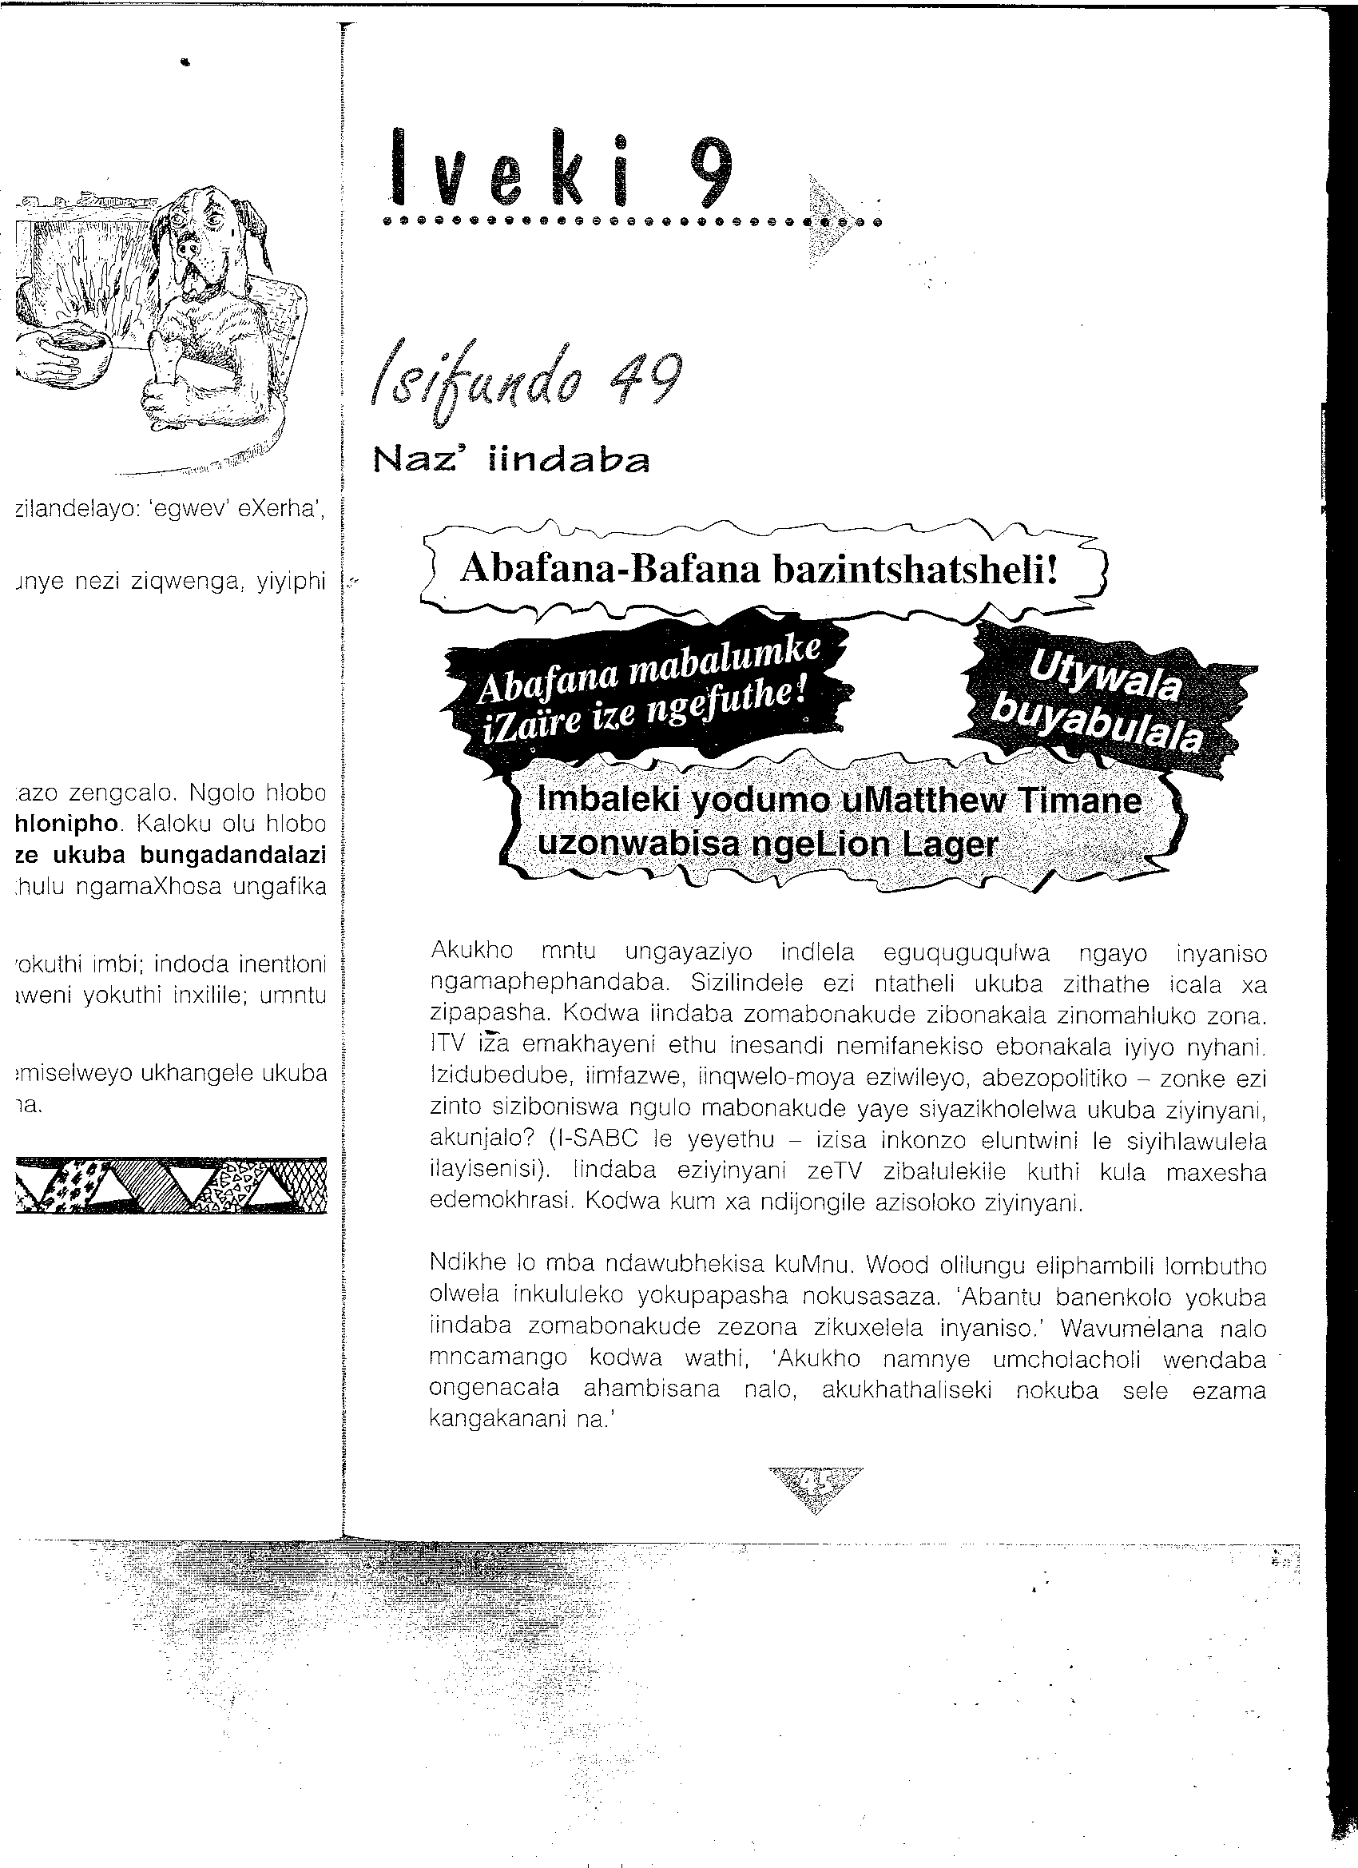
 | 4.1.1 | Lo mbhali uthi iTV ibhetele kunamaphepha xa sifuna inyaniso Kutheni esitsho nje? Xela izizathu zibembini. | (2)
 | 4.1.2 | Kufuneka ukuba ube nelayisensi xa ubukela i-SABC? | (2)
 | 4.1.3 | Kutheni kukho umcamango (imvo) wokuba iindaba zeTV zezona zikuxelela iinyaniso? | (2)
 | 4.1.4 | Utywala bulungile ebomini babantu? Kutheni usitsho nje? | (2)
4.2 | Phendula imibuzo usebenzise le grafu ilandelayo
 |  | 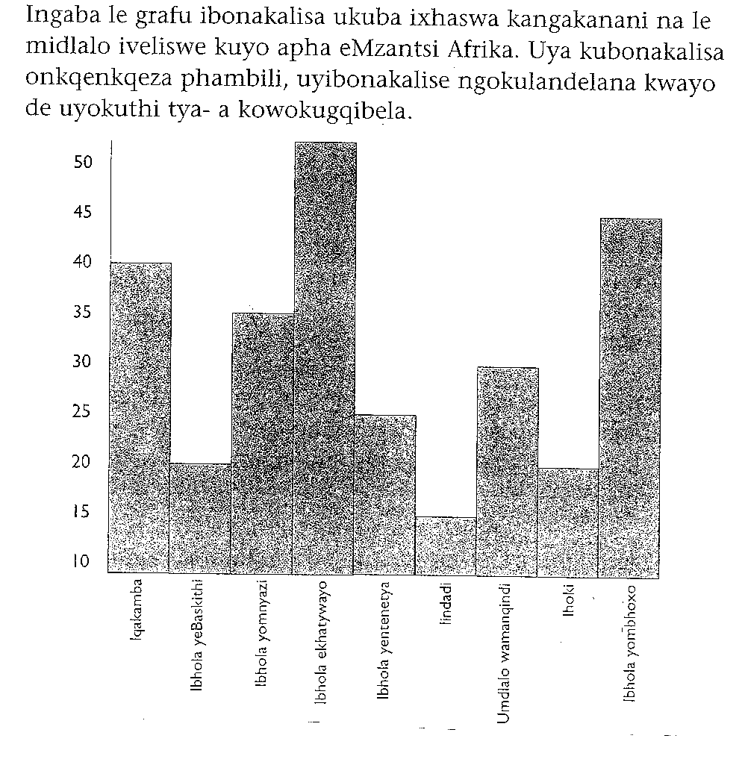
 | 4.2.1 | Nguwuphi umdlalo oxhaswa ngaphezu kweminye imidlalo? | 2
 | 4.2.2 | Ngowuphi umdlalo oxhaswa kancinci? | (2)
 | 4.2.3 | Yeyiphi imidlalo efana ngeepesenti malunga nokuxhaswa? | (2)
 | 4.2.4 | Uvumelana nam xa ndisithi ibhola yombhoxo ithandwa kakhulu  kweli lizwe? Kutheni usitsho nje? | (3)
 | 4.2.5 | Yintoni umahluko phakathi kwebhola yeBhaskiti nebhola  yomnyazi ngokwepesenti? | (2)
4.3 | Khetha elona gama lifanelekileyo kulawo akwizibiyeli (…).
 | 4.3.1 | Ilanga liyatshisa. Zonke iimpahla (zomile, zomisa). | (1)
 | 4.3.2 | (Xa, Nxa) ungathandi iTV kufuneka uyivale. | (1)
4.4 | Bhala igama eliNYE endaweni yala mabinzana.  Write ONE word for the following phrases.  Gee EEN word vir die volgende sinne.
 | 4.4.1 | Ukubuyela ekhaya emva kokusebenza. | (1)
 | 4.4.2 | Isithuthuthu, inqwelo-moya, ibhasi, itreyini, iteksi, imoto. | (1)
 | 4.4.3 | UMvulo, uMgqibelo, uLwesithathu, iCawa. | (1)

UMBUZO 5
5.1 | Khetha ngalo lonke ixesha amagama achanekileyo phakathi kwala akwizibiyeli.  Choose the correct words from the brackets.  Kies die korrekte word tussen hakies.
 | 5.1.1 | Abasebenzi basebenza ukususela ekuseni de kube ngokuhlwa. Sithi basebenza(imini yonke / imihla yonke) | (2)
 | 5.1.2 | Izithuthi zenziwa (ngesinyithi / sisinyithi /nesinyithi) | (2)
 | 5.1.3 | UNomsa uphumelele iimviwo zakhe.  (Siyavuyisana nawe! / Kubhetele utshonile! / Siyavelana nawe!) | (2)
 | 5.1.4 | UVuyani usesibhedlele emva kwengozi entabeni.  (Heke, ilungile loo nto! / Owu, ukuba lusizi torho! ) | (2)
5.2 | Bhala izichasi endaweni yala magama anomgca  ngaphantsi. Ungasisebenzisi isilanduli.  Write antonyms in the place of the underlined words.  Do not use the negative form.  Gee antonieme vir die onderstreepte woorde. Moenie die  negatief gebruik nie.
Umzekelo : Sihlala ngaphambili eklasini.
Impendulo : Sihlala ngasemva eklasini.
 | 5.2.1 | Ulwandle lwaseBhayi lucocekile. | (2)
 | 5.2.2 | Bekukho ababukeli abambalwa emdlalweni. | (2)
5.3 | Bhala izifanokuthi endaweni zala magama akrwelelweyo.  Write synonyms of the underlined words.  Gee die sinonieme van die woorde wat onderstreep is.
Umzekelo : Abafundi bahlohlwa ngutitshala wabo.
Impendulo : Abafundi bafundiswa ngutitshala wabo.
 | 5.3.1 | Ndivumelana nale nto yokungalwi esikolweni. | (2)
 | 5.3.2 | Ndifaka imali yam ebhankini. (4) | (2)
 |  | AMANQAKU ECANDELO C : 60

ICANDELO D : UNCWADI
Kwicandelo D makuphendulwe UMBUZO 6 okanye UMBUZO 7
UMBUZO 6
6.1 | UMZALI WOLAHLEKO : G.B. SINXO
Funda ezi zicatshulwa zilandelayo ngenyameko uze uphendule imibuzo ngezivakalisi ezizeleyo.

Read these following extracts carefully and then answer the questions in full Xhosa sentences.

Lees die volgende uittreksels noukeurig en beantwoord die vrae in vol Xhosa sine
 | UNdimeni yena zange aphume esikolweni, ngeli xesha uNdopho ahamba esithubeni. UNdimeni wayethandwa kakhulu ziititshala kuba wayekhuthele, enembeko. UNojaji waba nomona kakhulu yile nto, kuba uNdopho wayesoloko egxekwa; uNdimeni esoloko encoywa.
 | 6.1.1 | Yintoni isizathu sokuba uNdopho ahambe esithubeni? | (2)
 | 6.1.2 | UNdopho wasoloko egxekwa kodwa uNdimeni yena wasoloko enconywa.  Yintoni isizathu soko ngokuka Nojaji (according to)? Yeyiphi inyaniso? | (2)
 | 6.1.3 | Yadlula iminyaka emithathu ke, uNdopho waya phi? | (1)
6.2
UGakhulu wayenyanisile ukuthi uMenzile wayengakwazi
ukuphatha isithembu – ngakumbi esabantwana.
Wayengaphazami ukuthi uNojaji sisikhohlakali kodwa ke
wayephazama ukuyixela loo nto emntwaneni.

 | 6.2.1 | Yintoni isithembu? | (1)
 | 6.2.2 | Kutheni esithi uGakhulu uNojaji sisikhohlakali nje? | (1)
 | 6.2.3 | Kutheni ephazama ukuyixela le nto emntwaneni? | (2)
6.3 | Ezi zivakalisi ziyinyaniso okanye zibubuxoki. Xa zibuxoki, zilungise.
 | 6.3.1 | UNdopho wathi uNquphephe yimfama.
 | 6.3.2 | Umakhulu kaNdimeni nguNoseveni.
 | 6.3.3 | UJomsini wayekhumsha gqitha akunxila.
 | 6.3.4 | EBhayi uNdimeni wafumana umsebenzi elwandle. | /5/
6.4
Wabuyela kwakuNdimeni kwakhona, ehamba ezibetha esifubeni esithi,
“The friend that never troubles,
The horse that never stumbles,
The wife that never quarrels.”

Wafika wahlala phantsi, wajonga kumhlobo wakhe encumile, wathi,
“ Thina sine-experience ne-authorities ngezi zinto. Look-a-here, Demain
wena ufundiswe, ufundiswe kakhulu nguyihlo. Akunguye umntu wokuhlala apha, edolophini umana ukugxothwa ngabeLungu.
By Jupiter and by Mercury, ndinyanisile, and this boy is good op this earth.
Goduka uye kulima umhlaba kayihlo.

 | 6.4.1 | Ngubani lo ukhumsha apha? Lo mntu uthetha ngantoni xa esithi  “The friend …quarrels”? | (2)
 | 6.4.2 | Ngubani uyise kaNdimeni? Unike nesiduko (clan name )sakhe | (2)
 | 6.4.3 | Lo mntu uthethayo wanika uNdimeni icebiso (advise) elibalulekileyo. Lithini eli cebo? | (2) /6/
 |  | AMANQAKU : 20
 |  | OKANYE

UMBUZO 7
AMATHUNZI OBOMI : J J R JOLOBE
7.1 | Funda ezi zicatshulwa zilandelayo ngenyameko uze uphendule imibuzo elandelayo ngesiXhosa. Bhala izivakalisi ezizeleyo.
UMaDlomo : Hayi, mntwan’am, uza kubuya ubone wena. Kuza kubuya kulunge wena. Siza kubuya siphumelele nokuba kuya kuba ngexabiso elinzima. Kodwa simelwe kukuba siphile mntwan’am.

UNgxaki :Siza kuphila njani na, mama? Kutheni na ungandixeleli nje?

 | 7.1.1 | UMaDlomo wayesengxakini enkulu ekuqaleni kwencwadi. Kodwa ke wacinga icebo lokufumana imali. Yayiyintoni eli cebo? | (2)
 | 7.1.2 | UNgxaki wafuna ukwenza ntoni ukunceda umama wakhe? ntoni ukumncedisa? | (2)
 | 7.1.3 | Xela ngokufutshane awayekwenza uNgxaki xa abantu abathile besiza. | (3)
7.2
UKrila : Nkqo! Nkqo! Dlomo.

UMaDlomo : Ngaphakathi

 | 7.2.1 | Ngubani uKrila? Balisa ngaye. | (2)
 | 7.2.2 | UKrila wafika kuMaDlomo ukuxoxa naye umcimbi othile.  Wawungowuphi lo mcimbi? | (2)
 | 7.2.3 | Yayiyintoni ingxaki kaMaDlomo? Xela izinto ezimbini.
7.3
UNgxaki :Sibuyile ngoku, mama, siyozela kunjalo nje.

UMaDlomo :Nikholisile nibuye. Nango amashumi amabini
anesihlanu eesenti. Ngxaki, ungazifunela into oyifunayo. Nawe, Themba, nalo ishumi leesenti.

 | 7.3.1 | UMaDlomo unemali. Uyifumene njani? | (2)
 | 7.3.2 | Ngubani indoda eyayithenga ibranti kuye? Le ndoda yayithanda ukukhumsha. Yafuna ukuncedisa njani kwishishini likaMaDlomo? | (3)
 | 7.3.3 | UThemba wayengakwazi ukuzityhilela iBhayibile. Wancedwa njani nguMaDlomo? | (2)
 |  | AMANQAKU ECANDELO D : | 20
 |  | AMANQAKU EWONKE : | 120

ICANDELO A : UVAVANYO LOKUQONDA

UMBUZO 1

ISICATSHULWA A

UMABONAKUDE NEVIDIYO

Yonke imifanekiso nezandi ozonwabelayo kumabonakude zihambe zeza kufika kuyo ngomoya. Zihamba oku kwamaza onomathotholo. Amaza kanomathotholo luthotho lwemiqondiso ethunyelwa ngomoya. Le miqondiso icholwacholwa ieriyali yomabonakude. La maza onomathotholo avela kumazwe ngamazwe.

Le ndlela amaza onomthotholo athunyelwa ngayo kuthiwa kukusasaza. Unakho ukubukela usasazo kumabonakude ngexesha elinye kunye nabahlobo bakho. Ukuba ngaba kukho iindaba ezibalulekileyo okanye umdlalo obalulekileyo, abantu kwilizwe lonke banakho ukubukela ngeli xesha wenzeka ngalo.

Unakho ukubona abantu abaninzi obaziyo kumabonakude, kodwa kukho abanye abaninzi abasebenza kwakumabonakude ababuso babo ungasokuze ububone.

Yonke imifanekiso esiyibona kumabonakude yenziwe ngekhamera kamabonakude. Iyenza le nto ngokucholachola amaza okukhanya. La maza enziwa yimibala yento nganye efotwayo. Okunye ukukhanya okuwela kwezi zinto zifotwayo kuyacholwacholwa yinto leyo. Okunye ukukhanya kubuyiselwa umva. Koku kukhanya kwamaza kubuyiselwa mva oku kubangela imibala esiyibonayo kumabonakude.

La maza anokukhanya okubuyiselwe umva ungawahlula abe yimibala emithathu. Le mibala yile: ngobomvu, ngozuba kunye noluhlaza. Le mibala yimibala engavelanga ngokuxutywa kwemibala emibini.

Yonke eminye imibala oyibona kumabonakude yenziwe ngokudityaniswa imibala kunye nobomvu okanye ozuba okanye oluhlaza. Xa udibanisa ngokulinganayo le mibala mithathu ufumana umbala omhlophe.

IMIBUZO

 | 1.1.1 | Le mifanekiso ihamba njani ukuza kufika kumabonakude? | (2)
 | 1.1.2 | Yiyiphi imibala esetyenziswayo kumabonakude? | (2)
 | 1.1.3 | Indlela athunyelwa ngayo la maza sithi … | (2)
 | 1.1.4 | La maza acholacholwa yi … | (2)
 | 1.1.5 | Ingaba uthanda ukubukela umabonakude okanye ukumamela unothotholo? | (4)

ICANDELO A : UVAVANYO LOKUQONDA

UMBUZO 1

ISICATSHULWA A

UMABONAKUDE NEVIDIYO

Yonke imifanekiso nezandi ozonwabelayo kumabonakude zihambe zeza kufika kuyo ngomoya. Zihamba oku kwamaza onomathotholo. Amaza kanomathotholo luthotho lwemiqondiso ethunyelwa ngomoya. Le miqondiso icholwacholwa ieriyali yomabonakude. La maza onomathotholo avela kumazwe ngamazwe.

Le ndlela amaza onomthotholo athunyelwa ngayo kuthiwa kukusasaza. Unakho ukubukela usasazo kumabonakude ngexesha elinye kunye nabahlobo bakho. Ukuba ngaba kukho iindaba ezibalulekileyo okanye umdlalo obalulekileyo, abantu kwilizwe lonke banakho ukubukela ngeli xesha wenzeka ngalo.

Unakho ukubona abantu abaninzi obaziyo kumabonakude, kodwa kukho abanye abaninzi abasebenza kwakumabonakude ababuso babo ungasokuze ububone.

Yonke imifanekiso esiyibona kumabonakude yenziwe ngekhamera kamabonakude. Iyenza le nto ngokucholachola amaza okukhanya. La maza enziwa yimibala yento nganye efotwayo. Okunye ukukhanya okuwela kwezi zinto zifotwayo kuyacholwacholwa yinto leyo. Okunye ukukhanya kubuyiselwa umva. Koku kukhanya kwamaza kubuyiselwa mva oku kubangela imibala esiyibonayo kumabonakude.

La maza anokukhanya okubuyiselwe umva ungawahlula abe yimibala emithathu. Le mibala yile: ngobomvu, ngozuba kunye noluhlaza. Le mibala yimibala engavelanga ngokuxutywa kwemibala emibini.

Yonke eminye imibala oyibona kumabonakude yenziwe ngokudityaniswa imibala kunye nobomvu okanye ozuba okanye oluhlaza. Xa udibanisa ngokulinganayo le mibala mithathu ufumana umbala omhlophe.

IMIBUZO

 | 1.1.1 | Le mifanekiso ihamba njani ukuza kufika kumabonakude? | (2)
 | 1.1.2 | Yiyiphi imibala esetyenziswayo kumabonakude? | (2)
 | 1.1.3 | Indlela athunyelwa ngayo la maza sithi … | (2)
 | 1.1.4 | La maza acholacholwa yi … | (2)
 | 1.1.5 | Ingaba uthanda ukubukela umabonakude okanye ukumamela unothotholo? | (4)

ICANDELO A : UVAVANYO LOKUQONDA

UMBUZO 1

ISICATSHULWA A

UMABONAKUDE NEVIDIYO

Yonke imifanekiso nezandi ozonwabelayo kumabonakude zihambe zeza kufika kuyo ngomoya. Zihamba oku kwamaza onomathotholo. Amaza kanomathotholo luthotho lwemiqondiso ethunyelwa ngomoya. Le miqondiso icholwacholwa ieriyali yomabonakude. La maza onomathotholo avela kumazwe ngamazwe.

Le ndlela amaza onomthotholo athunyelwa ngayo kuthiwa kukusasaza. Unakho ukubukela usasazo kumabonakude ngexesha elinye kunye nabahlobo bakho. Ukuba ngaba kukho iindaba ezibalulekileyo okanye umdlalo obalulekileyo, abantu kwilizwe lonke banakho ukubukela ngeli xesha wenzeka ngalo.

Unakho ukubona abantu abaninzi obaziyo kumabonakude, kodwa kukho abanye abaninzi abasebenza kwakumabonakude ababuso babo ungasokuze ububone.

Yonke imifanekiso esiyibona kumabonakude yenziwe ngekhamera kamabonakude. Iyenza le nto ngokucholachola amaza okukhanya. La maza enziwa yimibala yento nganye efotwayo. Okunye ukukhanya okuwela kwezi zinto zifotwayo kuyacholwacholwa yinto leyo. Okunye ukukhanya kubuyiselwa umva. Koku kukhanya kwamaza kubuyiselwa mva oku kubangela imibala esiyibonayo kumabonakude.

La maza anokukhanya okubuyiselwe umva ungawahlula abe yimibala emithathu. Le mibala yile: ngobomvu, ngozuba kunye noluhlaza. Le mibala yimibala engavelanga ngokuxutywa kwemibala emibini.

Yonke eminye imibala oyibona kumabonakude yenziwe ngokudityaniswa imibala kunye nobomvu okanye ozuba okanye oluhlaza. Xa udibanisa ngokulinganayo le mibala mithathu ufumana umbala omhlophe.

IMIBUZO

 | 1.1.1 | Le mifanekiso ihamba njani ukuza kufika kumabonakude? | (2)
 | 1.1.2 | Yiyiphi imibala esetyenziswayo kumabonakude? | (2)
 | 1.1.3 | Indlela athunyelwa ngayo la maza sithi … | (2)
 | 1.1.4 | La maza acholacholwa yi … | (2)
 | 1.1.5 | Ingaba uthanda ukubukela umabonakude okanye ukumamela unothotholo? | (4)

ICANDELO A : UVAVANYO LOKUQONDA

UMBUZO 1

ISICATSHULWA A

UMABONAKUDE NEVIDIYO

Yonke imifanekiso nezandi ozonwabelayo kumabonakude zihambe zeza kufika kuyo ngomoya. Zihamba oku kwamaza onomathotholo. Amaza kanomathotholo luthotho lwemiqondiso ethunyelwa ngomoya. Le miqondiso icholwacholwa ieriyali yomabonakude. La maza onomathotholo avela kumazwe ngamazwe.

Le ndlela amaza onomthotholo athunyelwa ngayo kuthiwa kukusasaza. Unakho ukubukela usasazo kumabonakude ngexesha elinye kunye nabahlobo bakho. Ukuba ngaba kukho iindaba ezibalulekileyo okanye umdlalo obalulekileyo, abantu kwilizwe lonke banakho ukubukela ngeli xesha wenzeka ngalo.

Unakho ukubona abantu abaninzi obaziyo kumabonakude, kodwa kukho abanye abaninzi abasebenza kwakumabonakude ababuso babo ungasokuze ububone.

Yonke imifanekiso esiyibona kumabonakude yenziwe ngekhamera kamabonakude. Iyenza le nto ngokucholachola amaza okukhanya. La maza enziwa yimibala yento nganye efotwayo. Okunye ukukhanya okuwela kwezi zinto zifotwayo kuyacholwacholwa yinto leyo. Okunye ukukhanya kubuyiselwa umva. Koku kukhanya kwamaza kubuyiselwa mva oku kubangela imibala esiyibonayo kumabonakude.

La maza anokukhanya okubuyiselwe umva ungawahlula abe yimibala emithathu. Le mibala yile: ngobomvu, ngozuba kunye noluhlaza. Le mibala yimibala engavelanga ngokuxutywa kwemibala emibini.

Yonke eminye imibala oyibona kumabonakude yenziwe ngokudityaniswa imibala kunye nobomvu okanye ozuba okanye oluhlaza. Xa udibanisa ngokulinganayo le mibala mithathu ufumana umbala omhlophe.

IMIBUZO

 | 1.1.1 | Le mifanekiso ihamba njani ukuza kufika kumabonakude? | (2)
 | 1.1.2 | Yiyiphi imibala esetyenziswayo kumabonakude? | (2)
 | 1.1.3 | Indlela athunyelwa ngayo la maza sithi … | (2)
 | 1.1.4 | La maza acholacholwa yi … | (2)
 | 1.1.5 | Ingaba uthanda ukubukela umabonakude okanye ukumamela unothotholo? | (4)

ICANDELO A : UVAVANYO LOKUQONDA

UMBUZO 1

ISICATSHULWA A

UMABONAKUDE NEVIDIYO

Yonke imifanekiso nezandi ozonwabelayo kumabonakude zihambe zeza kufika kuyo ngomoya. Zihamba oku kwamaza onomathotholo. Amaza kanomathotholo luthotho lwemiqondiso ethunyelwa ngomoya. Le miqondiso icholwacholwa ieriyali yomabonakude. La maza onomathotholo avela kumazwe ngamazwe.

Le ndlela amaza onomthotholo athunyelwa ngayo kuthiwa kukusasaza. Unakho ukubukela usasazo kumabonakude ngexesha elinye kunye nabahlobo bakho. Ukuba ngaba kukho iindaba ezibalulekileyo okanye umdlalo obalulekileyo, abantu kwilizwe lonke banakho ukubukela ngeli xesha wenzeka ngalo.

Unakho ukubona abantu abaninzi obaziyo kumabonakude, kodwa kukho abanye abaninzi abasebenza kwakumabonakude ababuso babo ungasokuze ububone.

Yonke imifanekiso esiyibona kumabonakude yenziwe ngekhamera kamabonakude. Iyenza le nto ngokucholachola amaza okukhanya. La maza enziwa yimibala yento nganye efotwayo. Okunye ukukhanya okuwela kwezi zinto zifotwayo kuyacholwacholwa yinto leyo. Okunye ukukhanya kubuyiselwa umva. Koku kukhanya kwamaza kubuyiselwa mva oku kubangela imibala esiyibonayo kumabonakude.

La maza anokukhanya okubuyiselwe umva ungawahlula abe yimibala emithathu. Le mibala yile: ngobomvu, ngozuba kunye noluhlaza. Le mibala yimibala engavelanga ngokuxutywa kwemibala emibini.

Yonke eminye imibala oyibona kumabonakude yenziwe ngokudityaniswa imibala kunye nobomvu okanye ozuba okanye oluhlaza. Xa udibanisa ngokulinganayo le mibala mithathu ufumana umbala omhlophe.

IMIBUZO

 | 1.1.1 | Le mifanekiso ihamba njani ukuza kufika kumabonakude? | (2)
 | 1.1.2 | Yiyiphi imibala esetyenziswayo kumabonakude? | (2)
 | 1.1.3 | Indlela athunyelwa ngayo la maza sithi … | (2)
 | 1.1.4 | La maza acholacholwa yi … | (2)
 | 1.1.5 | Ingaba uthanda ukubukela umabonakude okanye ukumamela unothotholo? | (4)

