Province of the
EASTERN CAPE
EDUCATION
________________________________________________________________________________________________________
Assessment and Examinations, Bundy Park, Buffalo Road, Schornville, KWT
* Private Bag 4571*KWT * 5600* REPUBLIC OF SOUTH AFRICA
* Enquiries: Mr V A JOSEPH Tel: +27436047810/9 Fax:043 604 7789/08654664627
* Email:Varkeychan.Joseph@edu.ecprov.gov.za
____________________________________________________________________________________________________________________

CHIEF MARKER’S REPORT
INSTRUCTIONS

1. The Chief Markers are required to complete this report during the marking session. The aim of the report is to provide a feed back and to help subject advisors and educators to improve teaching and learning.
2. The report should be informed by discussions between the Chief Marker, moderator, senior markers and markers of the particular subject. NB: There should be one report per subject per paper.
3. The report must be detailed, informative and indicate question by question performance of the candidates and mark distribution of centres.
4. Reference may be made to the topics identified below as well as any aspect the Examiner wishes to bring to the attention of the subject advisors and educators.
5. The report must be submitted in hard copy and an electronic version to the centre manager at the marking centre.
6. All markers reports must be handed in with the hard copy.
7. The electronic report should be emailed to varkchan.joseph@edu.ecprov.gov.za
6. The centre managers then forward the reports to the Directorate of Assessment and Examination (Att: Mr. V A Joseph) in King William’s Town.

SUBJECT: | ISIXHOSA HOME LANGUAGE

GRADE: | 12 | PAPER: | 1

DATE OF EXAMINATION: | NOVEMBER 2009 | DURATION: | 21/2 HRS

1. ANALYSIS OF QUESTION BY QUESTION PERFORMANCE OF THE CANDIDATES

Give a detailed account of how the candidates performed in each question. In doing this, the following steps should be followed:

1.1 The aim/objective for setting the question (what skills, knowledge, values and attitudes were being tested by asking the question)

1.2 Relevance or relation of the question to the Los and Ass.

How did the candidates perform in the question?

1.3 Where did candidates lack expertise or fail in giving an appropriate answer to score high marks in the question?

UMBUZO1 UVAVANYO LOKUQONDA NOKUTOLIKWA KOMFANEKISO

Abafundi baqhube kakuhle kakhulu kulo mbuzo, bayiphendula kakuhle nemibuzo ebibuzwe

kumfanekiso kaBrenda. Abanye babo bawafumene onke la manqaku alo mbuzo kanti uninzi

belufumana amanqaku angama 22 – 26. Babe mbalwa kakhulu abafumene ngaphantsi kwamashumi amabini. Igalelo lootitshala ekufundiseni uvavanyo lokuqonda liyancomeka kakhulu.Amanqaku amaninzi abafundi bawufumene kulo mbuzo.

Nangona beqhube kakuhle nje abafundi kulo mbuzo, zikhona iingxaki ababenazo kule mibuzo ilandelayo:

1.1.3; 1.1.9 no 1.1.14

Umbuzo 1.1.3

Lo mbuzo ubufuna ukuba abafundi banike intsingiselo yegama “ukudyakraza” ngokwendlela elisetyenziswe ngayo kwisicatshulwa. Bona basuke banika isifanokuthi seli gama bathi ukuchitha/ukusetyenziswa, ndaweni yokucacisa ukuba lithetha ukuchithwa/ ukusetyenziswa kwemali kwizinto ezingenamsebenzi.

INGCEBISO:

Singootitshala masiyigxininise kubafundi into yokuba xa kufunwa intsingiselo yegama akufunwa sifanokuthi.

Umbuzo 1.1.9

Abafundi bathande ukuhola kulo mbuzo. Banike iingcinga zabo endaweni yokuphendula ngokwesicatshulwa njengoko umbuzo ubufuna.Banike iimpendulo ezifana nezi zilandelayo ezingekho kwisicatshulwa:

“Ndingamkhapha xa esiya kuthenga iincwadi.”

“Ndingamthengela ngokwam.”

INGCEBISO

Masiyibethelele kubafundi into yokuba xa umbuzo ufuna baphendule ngokwesicatshulwa, mabanike impendulo efumaneka kwisicatshulwa hayi izinto abazicingayo.

Umbuzo 1.1.14

Abafundi abaninzi abaqaphelanga ukuba awona magama abalulekileyo kulo mbuzo ngala: “Ngokweenjongo zikaRhulumente.” Bona bagxininise kwibinzana “ ukufunisa kumaziko emfundo ephakamileyo” baza banika impendulo ethi: “Imali yesibonelelo incinci.”

IINGCEBISO

Abafundi mabafundiswe ukuwucakaca umbuzo baqwalasele awona magama / mabinzana asisikhokelo.

UMBUZO 2 ISISHWANKATHELO

Lo mbuzo ubuvavanya izakhono zabafundi zokukwazi ukufunda;ukushwankathela bedwelisa iingongoma ezibalulekileyo besebenzisa awabo amazwi;ukusebenzisa iindidi zezivakalisi ezipheleleyo nezithungelanayo; ukusetyenziswa kolwimi,upelo, ukusetyenziswa kweempawu zobhalo ngokufanelekileyo.

Uninzi lwabafundi luqhube kakubi kulo mbuzo ngenxa yezi zizathu zilandelayo:
- Abakwazi ukukhetha iingongoma ezibalulekileyo kwesi sicatshulwa bazibeke ngawabo amazwi/ magama zithungelane.
- Bayoyiswa kukubhala izivakalisi ezipheleleyo.
- Babhala izivakalisi ezikwisicatshulwa njengoko zinjalo.
- Babhale ngezinto abazicingayo bona eziya kwenzeka xa kudlalelwa iNdebe yeHlabathi ngowama- 2010 bayiyeka le ikwisicatshulwa.
- Upelo olululo, ulwimi olugwenxa, ukusetyenziswa kweempawu zobhalo ngendlela efanelekileyo yingxaki enkulu kubo.
- Abayilandelanga imo ekuthiiwe mababhale ngayo. Abanye babhale ngokomhlathi nangona umbuzo ubufuna bachonge, badwelise iingongoma eziphambili, baza baphulukana nenqaku ngoko kunxaxha.
- Abawabhali tu/ ngokuchanekileyo amagama abawasebenzisileyo .

IINGCEBISO:
Isakhono sokukwazi ukushwankathela sibaluleke kakhulu kuba siyabanceda abafundi nakwezinye izifundo ezingelulo ulwimi.
- Abafundi mabaqhelaniswe nokufunda baze bashwankathele loo tekisi bayifundileyo.
- Makugxininiswe kulwakhiwo lwezivakalisi ezipheleleyo kusetyenziswa iindidi zezivakalisi.
- MasifundIswe isishwankathelo kusetyenziswe isiKhokelo seeMviwo sowama- 2009 sidityaniswe nesetyula (circular) E39 yowama-2009.

UMBUZO 3 IGRAMA NOKUSETYENZISWA KOLWIMI ENTETHWENI

Lo mbuzo ubugxile ekuvavanyeni isiPhumo sokuFunda sesiNe nemiGangatho yaso yokuHlola.

Kulo mbuzo uninzi lwabafundi lubonakalise ukungazi nto tu ngesiPhumo sokuFunda sesiNe.

Imibuzwana 3.1.3 no3.1.4 ibabethile.Mhlawumbi indlela obuzwe ngayo umbuzwana 3.1.3 ibabhidile kuba bekufunwa banike isigaba sentetho esisetyenzisiweyo endaweni yokuba basisebenzise kwisivakalisi njengoko iNkcazelo yeKharityulam isitsho.

IINGCEBISO:
- IsiPhumo sokuFunda sesiNe masifundiswe nemiGangatho yaso yokuHlola.

- Xa ootitshala bevavanya abafundi mababuze imibuzo esekwe kumxholo, bathathele ingqalelo okuchazwe kwimiGangatho yokuHlola.

UMBUZO 4

Abafundi baphendule ngcono kulo mbuzo, kodwa abakwazanga ukusebenzisa isibizo “inkampani” njengentloko nenjongosenzi. Injongosenzi abayazi tu yona.

INGCEBISO:

- Makufundiswe isiPhumo sokuFunda sesi-4 nemiGangatho yaso yokuHlola icokiswe.
- Xa kuvavanywa kuqwalaselwe isiKhokelo sesiFundo sokuHlola neNkcazelo yesifundo.

UMBUZO 5 ISIBHENGEZO - NTENGISO

Baphendule kakuhle abafundi kulo mbuzo kodwa boyiswa kukuphendula umbuzo 5.3 nombuzo 5.4.

5.3
Lo mbuzo ubufuna abafundi bachonge isaci esisetyenziswe kwisibhengezo - ntengiso abasinikiweyo.Abanye abafundi bacinge ukuba kufunwa izafobe baza banika impendulo ethi: “ esifa / okhatywe” kuphela.

5.4 Lo mbuzo ubufuna abafundi banike intsingiselo yesakhi u”nga” kwisenzi ebebesinikiwe.Uninzi lwabo boyisiwe kukuwuphendula / kukuwuphendula ngokuchanekileyo lo mbuzo.

INGCEBISO

- Makufundiswe isiPhumo sokuFunda sesi-4 nemigangatho yaso yokuHlola icokiswe.
- Xa kuvavanywa kuqwalaselwe iSAG neNkcazelo yesiFundo.

UMBUZO 6

UHLELO

Abafundi abaninzi bafumene amanqaku aphantsi kulo mbuzo. Abanye abawabonanga awona magama afuna ukulungiswa suka babhala angenaziphene bawafaka iziphene.

IINGCEBISO:

- Abafundi mabanikwe imisetyenzana yokuhlela qho kugxininiswa kwezi zinto: upelo, ubhalo lwezivakalisi, ukusetyenziswa kweziphumlisi.
- Mababizelwe amagama kugxininiswe kwiziqhakancu .

7. ANY ADVICE THAT YOU COULD GIVE TO EDUCATORS TO HELP
LEARNERS TO REACH THE EXPECTED LEVELS

- Abacebisi besiXhosa (Subject Advisors) mabacwangcise kunye nootitshala ekuqaleni konyaka kusetyenziswe ootitshala ababe nenyhweba yokumakisha kunyaka ophelileyo, kuxovulwe iingxaki abafundi abahlangabezene nazo kwesi sifundo.
- Kwizithili ekungekho baCebisi kuzo makusetyenziswe iititshala ezinamava nezo beziye kukorekisha.
- AbaCebisi besiXhosa kwizithili ezisondeleleneyo mabancedane ngokwabelana ngolwazi, kungabikho sithili sisilelayo kwizinto ezithile.
- Xa ootitshala bevavanya abafundi emagumbini mabasebenzise iSAG, Subject Statement, Examination Guidelines namaphepha eNKS yeminyaka edlulileyo neeExamplers ukuze abafundi baqhelane nendlela ekubuzwa ngayo kule NKS.
- Iintlanganiso zeeklasta (clusters) mazisetyenziswe ngootitshala babelane ngolwazi benze neemvavanyo ezifanayo ukunceda nabo bangakwaziyo ncam ukuvavanya ngokwale nkqubo intsha yezemfundo.
- IsiPhumo sokuFunda se-4 masifundiswe ezikolweni kuba abafundi basoloko bebonisa ukungazi kwimibuzo yegrama.
- Ingxaki yokufunda nokubhala inkulu kuninzi lwabafundi. Ootitshala ke ngoko mababanike ixesha elaneleyo lokufunda abafundi kanti ke babizelwe namagama bawabhale phantsi ngokukodwa iziqhakancu.

8. ANY OTHER COMMENTS

- Ootitshala mabazenzele iMemo kwiphepha ngalinye elibhaliweyo ngoNovemba/Disemba.
- Uqeqesho lootitshala phambi kokuba bamakishe amaphepha abafundi lube luncedo kakhulu, makuqhutyekwe nalo.

SIGNATURE OF EXAMINER/MODERATOR: _____________________________
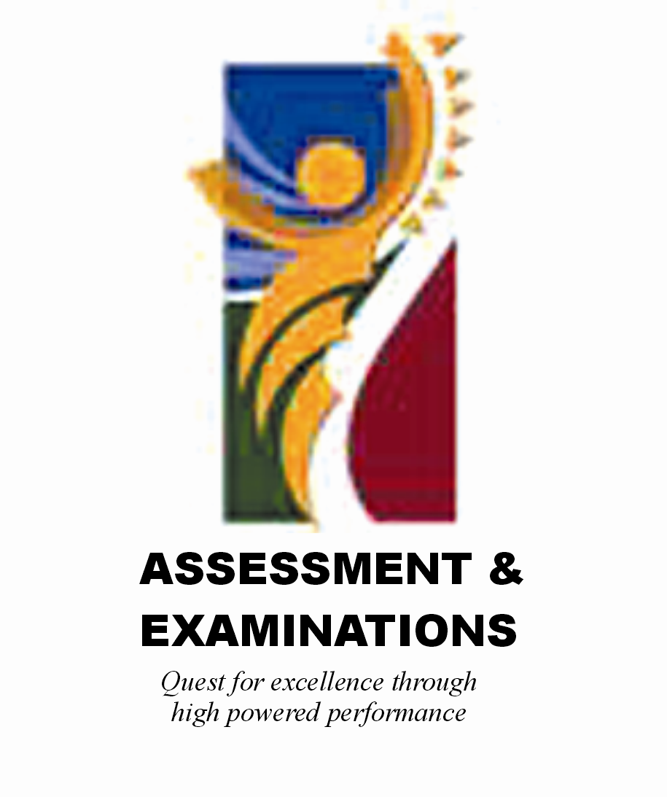 | SIYASEBENZISANA/ WORKING TOGETHER/ SAMEWERKING  Quest for Excellence through high powered performance

