Province of the
EASTERN CAPE
EDUCATION
________________________________________________________________________________________________________
Assessment and Examinations, Bundy Park, Buffalo Road, Schornville, KWT
* Private Bag 4571*KWT * 5600* REPUBLIC OF SOUTH AFRICA
* Enquiries: Mr V A JOSEPH Tel: +27436047810/9 Fax:043 604 7789/08654664627
* Email:Varkeychan.Joseph@edu.ecprov.gov.za
____________________________________________________________________________________________________________________

CHIEF MARKER’S REPORT
INSTRUCTIONS

1. The Chief Markers are required to complete this report during the marking session. The aim of the report is to provide a feed back and to help subject advisors and educators to improve teaching and learning.
2. The report should be informed by discussions between the Chief Marker, moderator, senior markers and markers of the particular subject. NB: There should be one report per subject per paper.
3. The report must be detailed, informative and indicate question by question performance of the candidates and mark distribution of centres.
4. Reference may be made to the topics identified below as well as any aspect the Examiner wishes to bring to the attention of the subject advisors and educators.
5. The report must be submitted in hard copy and an electronic version to the centre manager at the marking centre.
6. All markers reports must be handed in with the hard copy.
7. The electronic report should be emailed to varkchan.joseph@edu.ecprov.gov.za
6. The centre managers then forward the reports to the Directorate of Assessment and Examination (Att: Mr. V A Joseph) in King William’s Town.

SUBJECT: | IsiXhosa Home Language

GRADE: | 12 | PAPER: | 3

DATE OF EXAMINATION: | Nov. 2009 | DURATION: | 2.5Hours

1. ANALYSIS OF QUESTION BY QUESTION PERFORMANCE OF THE CANDIDATES

Give a detailed account of how the candidates performed in each question. In doing this, the following steps should be followed:

1.1 The aim/objective for setting the question (what skills, knowledge, values and attitudes were being tested by asking the question)

1.2 Relevance or relation of the question to the Los and Ass.

How did the candidates perform in the question?

1.3 Where did candidates lack expertise or fail in giving an appropriate answer to score high marks in the question?

QUESTION 1

SECTION A - ESSAYS

From this section eight different questions were asked and each candidate had to choose only one.

  - This question was set to test the following:

- Creativity
- Planning
- Awareness of their environment and what happens around them
- Appreciation of nature
- Skill – Argue for and against
- Comparison between two things
- Value of nature
- Love for nature
- Value – Attitude towards nature

This question has covered NCS because it succeeded in bringing/digging out from the learners the knowledge of things related to nature.

On questioning - The question was well posed except that the pictures limited their thinking (those who concentrated on the pictures only) since they only wrote about tigers, lions and aloes.

In this question learners showed how they value nature in what they have written.

Their attitude towards nature was also shown, they love nature and appreciate it.

Leaners’ responses showed insight into the topic and it was fairly performed.

(Please see attached score sheet)

LO3 AS 1 SS 4, 6, 8,

3 AS 2 SS 1, 2, 3,4,5,6.

3 AS 3 SS 2, 3,5, 6,8

LO 4 AS 1 SS 5, 6

  - This question was set to test the following:
- Identifying the problem
- Skill – Problem solving
- Convincing ideas required
- Co-operation
- Value – positive attitude
- Knowledge
- Imagination
- Sense of responsibility
- Skill – to narrate logically, systematically and showing coherence
On questioning - This was a very straight forward question.
The fact that learners wrote about ‘Inkanyamba’ as if they were there or have an experience with it – shows a skill of imagination in them.
Most of them never saw ‘Inkanyamba’ but the way they wrote about it, how it starts, what happens, its impact on the lives of people, animals and the effects of the tragedy really showed their imagination.
Learners’ responses showed a high level of maturity as prescribed by Developmental Outcome 2 in the National Curriculum Statement.
They did very well in this question.
LO3 AS 1 SS 4, 6,

3 AS 2 SS 1, 2, 3,4,5,6.

3 AS 3 SS 2, 3,5, 6,8

LO 4 AS 1 SS 5, 6
4 AS 2 SS 2,4,5,9,10,11,12
  - ‘Imfundo ayikhulelwa ............... Xoxa kuvokotheke ngalo mbandela’
This topic is supposed to be expository but the word ‘xoxa’ changes the type of an essay as this statement ‘imfundo ayikhulelwa’ does not have the features of argumentative type of writing.
‘Xoxa’ after the statement given therefore seems to be confusing because there is nothing to debate about – there is nothing to agree or disagree with the statement given.
Learners were not disadvantaged by this because of the recommendations of the National DOE that focus should not be on the type of essay but on the other aspects, i.e. contents and design, language, structure, style and editing.
This question was fairly performed.
LO3 AS 1 SS 4, 6,9

3 AS 2 SS 1, 2, 3,4,5,6.

3 AS 3 SS 2, 3,5, 6,8

LO 4 AS 1 SS 5, 6
- AS 2 SS 2,4,5,9,10,11,12
  - This question was set to test the following:
- Planning
- Commitment
- Organisational skills
- Patriotism
- Identifying the problem
- Skill – problem solving; leadership; time management
- Convincing ideas
- Value – decision making; positive attitude;Mission

In this question the learner is expected to reflect on his/her dreams based on
an idea and explain how he/she would actualised his/her dreams.
Most of the learners chose this topic. They showed knowledge of what is happening in their country, what needs to be done, what people need or want or expect from a president and promises that were fulfilled or not.
Learners performed very well in this question showing that level of developed prescribed by the Developmental Outcome 2 in the National Curriculum Statement.
LO3 AS 1 SS 4, 6,

3 AS 2 SS 1, 2, 3,4,5,6.

3 AS 3 SS 2, 3,5, 6,8

LO 4 AS 1 SS 5, 6
- AS 2 SS 2,4,5,9,10,11,12
1.5.This question was set to test the following:
- Skill – argue for or against (reasoning)
- Creativity
- Identifying the problem
- Solving the problem
On questioning – In this question there is a phrase that says’ Ingaba uphumelele na ukufezekisa izithembiso zakhe’ The response expected is either agree or disagree but the last part of the question which reads’Bhala isincoko ubonisa indima ayidlalileyo ekuphuculeni ubomi babantu’ seems to be driving learners to agree.
This question is related to question 1.4. This is evidence in learners’ responses.
The phrasing of the question did not disadvantage the learners and this was one of the popular questions chosen by the learners.
The learners did well in this question.
LO3 AS 1 SS 4, 6,

3 AS 2 SS 1, 2, 3,4,5,6.

3 AS 3 SS 2, 3,5, 6,8

LO 4 AS 1 SS 5, 6
- AS 2 SS 2,4,5,9,10,11,12
1.6.This question was set to test the following:
- Knowledge
- Values – attitude
- Appreciation
- Patriotism
The learners showed knowledge about sport and the coming FIFA World Cup. Those who chose this essay know a lot and are clear about sport. They have a positive attitude towards this World Cup – mentioning the benefits from it.
They performed well.
LO3 AS 1 SS 4, 6,

3 AS 2 SS 1, 2, 3,4,5,6.

3 AS 3 SS 2, 3,5, 6,8

LO 4 AS 1 SS 5, 6
4 AS 2 SS 2,4,5,9,10,11,12
1.7. & 8. This is a free genre type of text. Learner gave relevant topics to the pictures provided and wrote essays of their choice. Very few chose 1.8.

In 1.7 they showed knowledge about cell phones and they know everything about its advantages and disadvantages(cell phones)
Those who chose 1.7 did very well

QUESTION 2

SECTION B – LONGER TRANSACTIONAL TEXTS

This question was fair to all candidates.

It is without doubt of appropriate standard for Grade 12 NCS candidates.

Questions were all testing application of knowledge of candidates as they were outcomes based. Questions were fair in that they were testing candidates on the real life situation as some of them are heading to the world of work

Guidance was give in the question as what is expected.

2.1. MEMORANDUM

This question was performed well.

2.2. OFFICIAL LETTER

The performance was fairly well although learners still have a problem with the writing of the second address and the addressee. Some candidates failed to realise that the editor to whom their concerns must be addressed has nothing to do with government services hence they pleaded with him/her to take action

rather than to publicise their concern.

2.3.OBITUARY

This was a popular choice in this section.

Some centres used the first person style in writing the obituary – something that needs to be corrected because it should act as a report rather than the direct speech it was.

2.4. CV

There was a tendency but the layout was of a good standard

LO 3 AS 2 SS 2,3,4,5,6,

AS 3 SS 3,5,7,8

QUESTION 3

SECTION C
This question was set to test the following:
- Creativity
- Advertising
- Skills – Marketing
- Values – cooperation
- Love for art
- Discipline
- Writing skills
- Team work
The performance in this section was good except for diary entries. Learners seem not to have an idea on how to make entries.
In 3.1 & 3.3(Invitation card and poster)learners showed creativity – Love for art

CRITICAL OUTCOMES

1 | 2 | 3 | 4 | 5
 | ESSAYS | ESSAYS | ESSAYS | ESSAYS
 | C& B | C& B | C& B
 | C & C | C& C | C &C | C & C
DEVELOPMENTAL OUTCOMES
1 | 2 | 3 | 4 | 5 | 6 | 7
ESSAYS | ESSAYS | ESSAYS | ESSAYS |  | ESSAYS | ESSAYS
C & B | C& B | C& B | C & B |  | C &B | C &B
 | C &C | C & C | C &B |  | C &C

SIGNATURE OF EXAMINER/MODERATOR: _____________________________

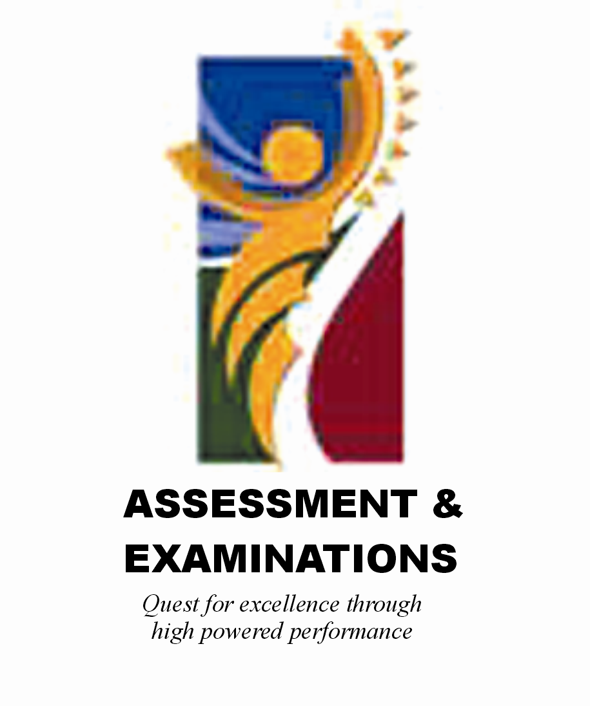 | SIYASEBENZISANA/ WORKING TOGETHER/ SAMEWERKING  Quest for Excellence through high powered performance

