Province of the

EASTERN CAPE
EDUCATION
________________________________________________________________________________________________________
Assessment and Examinations, Bundy Park, Buffalo Road, Schornville, KWT
* Private Bag 4571*KWT * 5600* REPUBLIC OF SOUTH AFRICA
* Enquiries: Mr V A JOSEPH Tel: +27436047810/9 Fax:043 604 7789/08654664627
* Email:Varkeychan.Joseph@edu.ecprov.gov.za
____________________________________________________________________________________________________________________

CHIEF MARKER’S REPORT
INSTRUCTIONS

1. The Chief Markers are required to complete this report during the marking session. The aim of the report is to provide a feed back and to help subject advisors and educators to improve teaching and learning.
2. The report should be informed by discussions between the Chief Marker, moderator, senior markers and markers of the particular subject. NB: There should be one report per subject per paper.
3. The report must be detailed, informative and indicate question by question performance of the candidates and mark distribution of centres.
4. Reference may be made to the topics identified below as well as any aspect the Examiner wishes to bring to the attention of the subject advisors and educators.
5. The report must be submitted in hard copy and an electronic version to the centre manager at the marking centre.
6. All markers reports must be handed in with the hard copy.
7. The electronic report should be emailed to varkchan.joseph@edu.ecprov.gov.za
6. The centre managers then forward the reports to the Directorate of Assessment and Examination (Att: Mr. V A Joseph) in King William’s Town.

SUBJECT: | XHOFA

GRADE: | 12 | PAPER: | 02

DATE OF EXAMINATION: | 17/ 11/ 2009 | DURATION: | 2Hrs

1. ANALYSIS OF QUESTION BY QUESTION PERFORMANCE OF THE CANDIDATES

Give a detailed account of how the candidates performed in each question. In doing this, the following steps should be followed:

1.1 The aim/objective for setting the question (what skills, knowledge, values and attitudes were being tested by asking the question)

1.2 Relevance or relation of the question to the Los and Ass.

How did the candidates perform in the question?

1.3 Where did candidates lack expertise or fail in giving an appropriate answer to score high marks in the question?

QUESTION 1

- Test their understanding of the contents of the book.
- Application of the content to real life situation
- LO 2, 3, and 4, DO2 and AS1 and 2
- Not many candidates answered question 1. Most of the candidates did not understand the meaning of the Idiom used in the Essay. “ Umntu ulilahle elinothuthu.”

QUESTION 2

- Test their understanding of the content.
- LO.2,3 and AS1 and 2
- The candidates scored high marks in this Question and this shows that the candidates were well prepared.

QUESTION 3.

- To test the understanding of the content.
- Application of the content to real life situation.
- LO2 ,3,4, and AS 1 and 2
- Few candidates answered and scored high marks in this Question.
- Candidates tend to narrate the whole story, not understanding or not focusing to what is expected by the question.

QUESTION 4

- To test the understanding of the content.
- LO.3 and AS1 and 2
- Well answered.
- Very easy questions, with some answers available in the given extracts.

QUESTION 5

- To test their understanding of the book.
- LO.3 and 4 and AS 1 and 2
- Poorly answered. Learners did not understand the idiom used although it is highly expected that Educators should have explained it as it is the main theme of the book.

QUESTION 6

- To test their understanding of the book.
- LO.3,4 and AS 1 and 2
- Well answered.
- This Question and Q4 were the most common combinations. The questions were simple and easy to understand

QUESTION 7

- To recall and apply their understanding of the content to real life situation.
- Lo.3,4 and AS1 and 2
- Poorly answered. It seems as if there was a problem of availability with this book as many schools didn’t do it at all.

QUESTION 8

- Poorly answered. As stated above that there was a problem of availability of books very few learners attempted this question.

QUESTION 9

- To Test their understanding on how to analyse a poem, figures of speech. The meaning of certain words and the theme of the poem.
- LO.3,4 and AS 1,2,3 and 4
- Well answered. Most candidates scored high marks in this question. Few Learners failed to identify the difference between literary and figurative meanings.

QUESTION 10

- Analyse and answer questions from the poems given (similar to above explanation given in Question 9)
- Lo.3,4 and AS1 ,2 3, and 4
- Candidates tend to answer the questions using lines directly from the poem and this shows the lack of knowledge of figures of speech.

QUESTION 11

- Analyse and answer questions from the poems given (similar to above explanation given in Question 9)
- Lo.3,4 and AS1 ,2 3, and 4
- Candidates tend to answer the questions using lines directly from the poem and this shows the lack of knowledge of figures of speech.

QUESTION 12

- Analyse and answer questions from the poems given (similar to above explanation given in Question 9)
- Lo.3,4 and AS1 ,2 3, and 4
- Candidates tend to answer the questions using lines directly from the poem and this shows the lack of knowledge of figures of speech.

7. ANY ADVICE THAT YOU COULD GIVE TO EDUCATORS TO HELP
LEARNERS TO REACH THE EXPECTED LEVELS.

It is highly recommend that teachers should be in possession of the NCS and SAG documents for guidance. Classroom debates and discussions are also highly recommended. The educators should try to inculcate the culture of learning in their schools as there is no way the learners could fully know literature without learning on their own.

8. ANY OTHER COMMENTS

SIGNATURE OF EXAMINER/MODERATOR: _____________________________

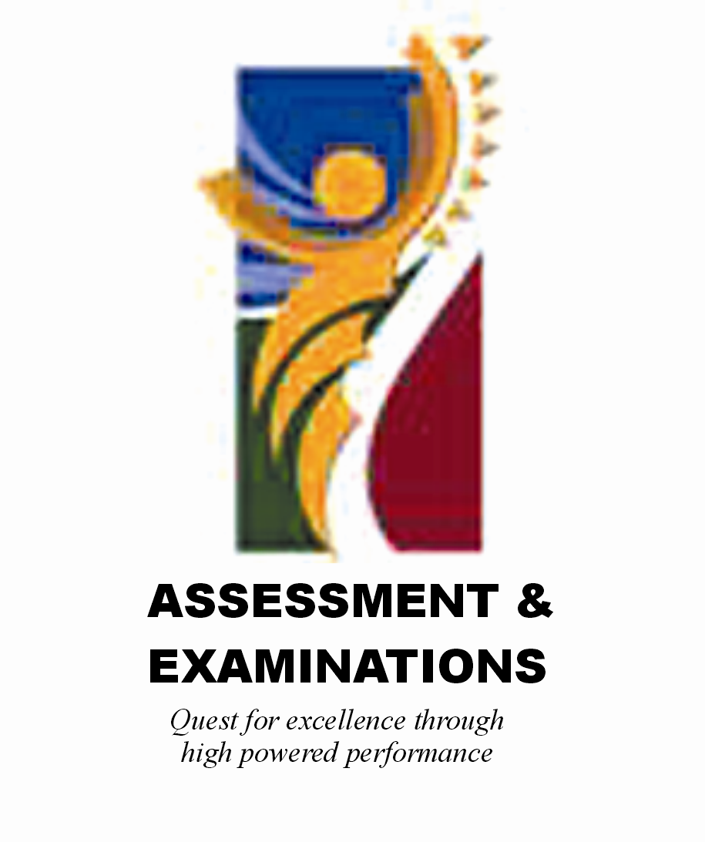 | SIYASEBENZISANA/ WORKING TOGETHER/ SAMEWERKING  Quest for Excellence through high powered performance

