Province of the
EASTERN CAPE
EDUCATION
________________________________________________________________________________________________________
Assessment and Examinations, Bundy Park, Buffalo Road, Schornville, KWT
* Private Bag 4571*KWT * 5600* REPUBLIC OF SOUTH AFRICA
* Enquiries: Mr V A JOSEPH Tel: +27436047810/9 Fax:043 604 7789/08654664627
* Email:Varkeychan.Joseph@edu.ecprov.gov.za
____________________________________________________________________________________________________________________

CHIEF MARKER’S REPORT
INSTRUCTIONS

1. The Chief Markers are required to complete this report during the marking session. The aim of the report is to provide a feed back and to help subject advisors and educators to improve teaching and learning.
2. The report should be informed by discussions between the Chief Marker, moderator, senior markers and markers of the particular subject. NB: There should be one report per subject per paper.
3. The report must be detailed, informative and indicate question by question performance of the candidates and mark distribution of centres.
4. Reference may be made to the topics identified below as well as any aspect the Examiner wishes to bring to the attention of the subject advisors and educators.
5. The report must be submitted in hard copy and an electronic version to the centre manager at the marking centre.
6. All markers reports must be handed in with the hard copy.
7. The electronic report should be emailed to varkchan.joseph@edu.ecprov.gov.za
6. The centre managers then forward the reports to the Directorate of Assessment and Examination (Att: Mr. V A Joseph) in King William’s Town.

SUBJECT: | ISIXHOSA FIRST ADDITIONAL LANGUAGE

GRADE: | 12 | PAPER: | 3

DATE OF EXAMINATION: | 26 NOVEMBER 2009 | DURATION: | 2HRS 30MIN

1. ANALYSIS OF QUESTION BY QUESTION PERFORMANCE OF THE CANDIDATES

Give a detailed account of how the candidates performed in each question. In doing this, the following steps should be followed:

1.1 The aim/objective for setting the question (what skills, knowledge, values and attitudes were being tested by asking the question)

1.2 Relevance or relation of the question to the Los and Ass.

How did the candidates perform in the question?

1.3 Where did candidates lack expertise or fail in giving an appropriate answer to score high marks in the question?

QUESTION 1

The aim for setting question 1 is to assess the creative thinking and application of creative thinking in writing. All the kinds of essays that cover the NCS syllabus were included. L0S 2, 3 and 4 are covered and also AS 1, 2 and 3. The questions 1.1 to 1.8 were fairly asked and guidelines on how to answer the questions were clearly given. The candidates performed fairly well. The candidates lack expertise in following the instructions, interpretation and understanding of the questions, therefore they lose content which leads to poorly written essays. For example, Question 1.1 was given in dialogue form and the learner was required to complete it by writing an essay, not a dialogue. Some learners wrote a dialogue. Question 1.6 had pictures of musical instruments. The learner had to interpret what they saw in all the pictures combined, but some learners chose one instrument which lead to repetition of facts within the essay. Their creative writing skills are poor e.g language, punctuation, spelling, word division, sentence construction etc. They also tend to begin topic sentences with conjunctions like ‘BUT’. Their failure to apply cognitive and writing skills caused them to obtain low marks.

QUESTION 2

The objective for setting this question is to assess the functional writing skills. LO 2, 3 and 4 and AS 1, 2 and 3 are covered. This question was also fairly asked with illustrative guidelines. The candidates lack expertise in giving appropriate answers to obtain high marks in the following: 1. Planning 2. Formats for longer transactional writing 3. Spelling 4. Editing 5. Language usage 6. Content. For example, the report in question 2.2 was mistaken for a formal letter. There is a possibility that the learners were confused with the way this particular question was asked. The instructions included the word “BHALELA” which had the potential to mislead the learner to thinking that a formal letter was to be written. The film review in Question 2.4 was also incorrectly done as they did not follow the standard format. The orbituary was written in the first person. They were also given a specific instruction on what the orbituary was about, but they did not follow that. In other words, they wrote about a female instead of a male and they also made up their own cause of death while they were specifically given one. The format of the formal letter was well done but the candidates failed to adhere to the instructions because they were off topic.

QUESTION 3.

The aim for setting this question is to assess shorter transactional writing skills. The question is relevant to LO 2, 3 and 4 and also AS 1, 2 and 3 that are required by NCS. This question was also clear with guidelines. The candidates lack expertise in giving appropriate answers to obtain high marks in the following: Formats, planning, language usage and editing. The candidates confused the format of the invitation with the notice. They also did not know of the format of the postcard as well as the diary.

QUESTION 4

QUESTION 5

QUESTION 6

QUESTION 7

QUESTION 8

QUESTION 9

QUESTION 10

QUESTION 11

QUESTION 12

- ANY ADVICE THAT YOU COULD GIVE TO EDUCATORS TO HELP
LEARNERS TO REACH THE EXPECTED LEVELS.

- To be taught to adhere to the instructions of the question paper and to the questions as well.
- To be encouraged to plan their work in all sections before they can answer the questions.
- To stick to the chosen topic and not to deviate from it.
- To practise spelling from the beginning of the first term
- To teach them the formats of writing all sections i.e longer and shorter transactional texts.

8. ANY OTHER COMMENTS

SECTION A

All types of essays must be taught even if they are not formally assessed.

SECTION B & C

All formats for all pieces must be taught in order to give the learner a wider scope in answering the question.

SIGNATURE OF EXAMINER/MODERATOR: _____________________________

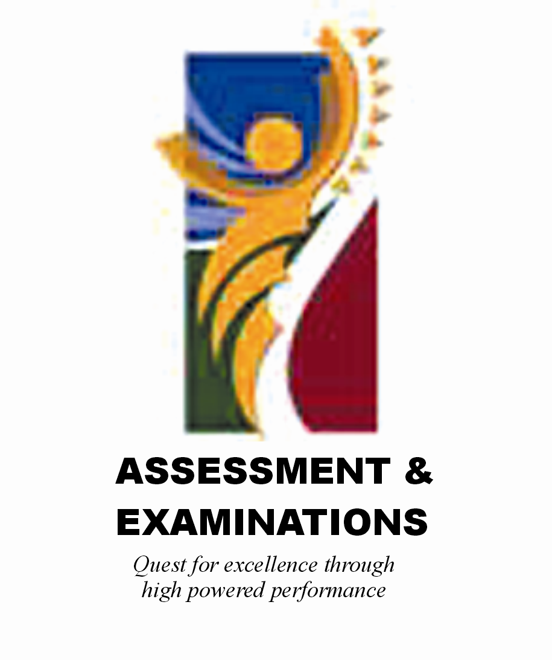 | SIYASEBENZISANA/ WORKING TOGETHER/ SAMEWERKING  Quest for Excellence through high powered performance

