Province of the
EASTERN CAPE
EDUCATION
________________________________________________________________________________________________________
Assessment and Examinations, Bundy Park, Buffalo Road, Schornville,* Private Bag 4571*KWT * 5600* REPUBLIC OF SOUTH AFRICA * Enquiries: Mr V A JOSEPH Tel: +27 (0)43 604 7810/9 Fax: 043 6047789/086 5466 4627* Date: 26 November 2008* Email:Varkeychan.Joseph@edu.ecprov.gov.za
____________________________________________________________________________________________________________________

EXAMINER’S REPORT

INSTRUCTIONS

1. The Chief Examiners are required to complete this report during the marking session. The aim of the report is to provide a feed back and to help subject advisors and educators to improve the teaching and learning.
2. The report should be informed by discussions between the Examiner, moderator, senior markers and markers of the particular subject. NB: There should be one report per subject per paper.
3. The report must be detailed, informative and question by question performance of the candidates.
4. Reference may be made to the topics identified below as well as any aspect the Examiner wishes to bring to the attention of the subject advisors and educators.
5. The report must be submitted in hard copy and an electronic version to the centre manager at the marking centre.
6. The centre managers then forward the report to the Directorate of Assessment and Examination (Att: Mr. V A Joseph) in King William’s Town.

SUBJECT: | ISIXHOSA SECOND ADDITIONAL LANGUAGE

GRADE: | 12 | PAPER: | 1

DATE OF EXAMINATION: | 4/ 11/2009 | DURATION: | 2 ½hours

1. STANDARD OF THE QUESTION PAPER. Was the paper of an appropriate standard for Grade 12? Substantiate

The standard of the questions was very high. The non mother tongue learners have found it very difficult to understand the instructions. They could not have obtained enough vocabulary over the years to answer a paper at this level.

2. COVERAGE OF NATIONAL CURRICULUM STATEMENT. Does the paper cover the prescribed Learning Outcomes and Assessment Standards? If your answer is no, indicate which Learning Outcomes or Assessment Standards were not adequately covered?

This seems to be a problem. Teachers must make sure they are working according to the document policy. Grammar seems to have become very important and a lot of time should be spent on this section.

- UNFAIR QUESTIONS: Were there any questions that were either inaccurate, ambiguous, outside the NSC or beyond the level of Grade 12. List these questions, with motivation.

Question 1 ( isicathulwa B ) was difficult for a second additional learner. The interpretation of the pictures was difficult. This was seen in the answering of the paper.

Question 3.4 Second Additional learners did not know the terminology.

Teacher can maybe teach them this although we as group feel that this is not part of assessment. If this has to be taught then National must put this on paper to teachers.

- LANGUAGE. Is the language used appropriate for Grade 12 learners? List questions that were linguistically complex and show how these questions can be re-phrased.

The language was difficult. The learners did not understand the instructions because all the questions were set in Xhosa. According to Mrs P Entley, learners’ knowledge should be tested and not their interpretations. This must be address.

- LENGTH OF QUESTION PAPER. Were candidates able to complete the question paper in the stipulated time?

There was no evidence that the learners could not finish in time.

- MARKING GUIDELINE. Does the marking guideline cater for all alternative responses?

The group had to settle for the national memo.

There were answers given by the learners which could have been accepted, but were not.

We were told it was a close memo. Discussed by nationals.

We were unsure about spelling. The memo did not state if deductions had to be made.

Suggestion: Nationals must get in contact with markers.

7. ANALYSIS OF QUESTION BY QUESTION PERFORMANCE OF THE CANDIDATES

Give a detailed account of how the candidates performed in each question. In doing this, the following steps should be followed:

7.1 The aim/objective for setting the question (what skills, knowledge, values and attitudes were being tested by asking the question)

7.2 Relevance or relation of the question to the Los and ASs.
    - How did the candidates perform in the question?

7.4 Where and how did candidates lack or fail in giving an appropriate answer to score high marks in the question?

QUESTION 1

The learners needed vocabulary at the end of the comprehension to guide them

e.g. 1.1.10 SAL learners found this difficult. 1.1.13 Ibhizana They did not know this.

  - Majimbo-humour is always difficult to understand and interpret if it is not your culture

QUESTION 2

The learners did well in this question.

QUESTION 3.

This question dealt with formal grammar and a lot of the learners do not know their grammar ( LO 4 ).

3.4 No example was given and the learners did not do well.

Make sure all the grammar in LO 4 is taught.

Learners did not do well in 3.5. It is not expected of SAL learners to learn terminology. They could not answer this question. Do not know if this is clear to teachers

Cluster sessions can solve this problem

3.6 A lot of interpretation was expected and not just translation. A poor leaner would have found this difficult.

3.9 No examples were given. The learners did not do well.

Learners struggled with grammar.
  - The same as what happened in 3.6. they really struggled. Cluster meetings could be of help here.
  - Idioms seem to be difficult for SAL learners. A lot of exercises is needed.

There are no guidelines from the document policy as to what idioms. Seeing that no books are prescribed the learners have to guess. Not good.

QUESTION 4

The questions on the book were fair. Learners seem to learn answers off by heart without really understanding the book. 4.2.1 was a bit confusing. They had to interpret answer.
4.2.2 Difficult grammar was used for SAL learners to answer the question.

QUESTION 5

The questions on the book was fair. The language used, made it easy for the learners to give their knowledge of the book.
Learners seem to learn questions off by heart and then find it difficult to answer the specific question. Teachers have to address this.
5.3.1 The learners found this difficult

QUESTION 6

QUESTION 7

QUESTION 8

QUESTION 9

QUESTION 10

QUESTION 11

QUESTION 12

7. ANY ADVICE THAT YOU COULD GIVE TO EDUCATORS IN HELPING THE
LEARNERS TO REACH THE EXPECTED LEVEL.

Teachers must make sure that the learners know the vocabulary of the literature and not just the questions that were worked out before hand.

Give a lot of tests on the book.

Make sure you and the learners know the document policy. Specially LO 4

This will help learners to formulate own answers.

Take one article and teach the grammar that occurs in that piece.

Keep on doing so until you are sure that you have done all the grammar expected as set out in policy document,

8. ANY OTHER COMMENTS

Workshops can be of great help.

Teachers from different provinces could meet once a year with national to get clarity on expectations and maybe have a workshop

NB Problems:

The examplar papers were different from the national papers. National must address this and help teacher as far as possible.

Teaching was based on these papers throughout the year.

Learners and teachers were misled.

It would be of great help if examiners of the national papers were to have

A workshop for the facilitators throughout all the provinces.

We cannot allow this wonderful subject to disappear the NSC curriculum.

Mrs. M Landman

SIGNATURE OF EXAMINER/MODERATOR: _____________________________

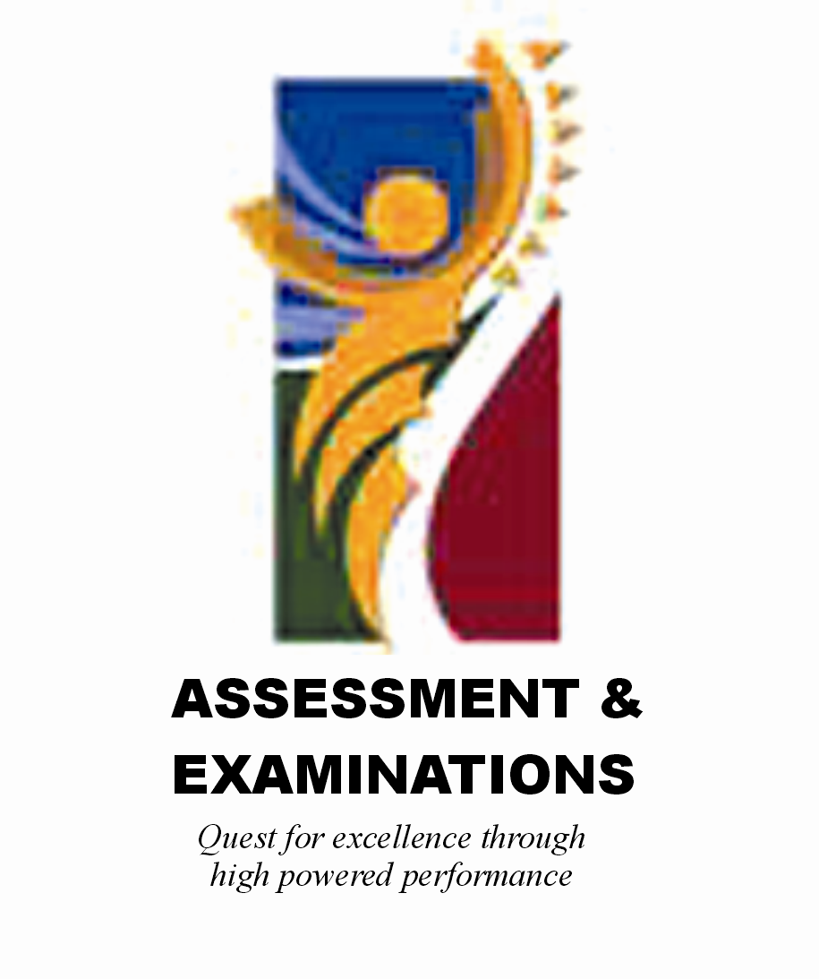 | SIYASEBENZISANA/ WORKING TOGETHER/ SAMEWERKING  Quest for Excellence through high powered performance

