XHOFA

ISEBE LEMFUNDO LEMPUMA KOLONI
EASTERN CAPE EDUCATION DEPARTMENT
OOS-KAAP ONDERWYSDEPARTEMENT

IIMVIWO ZEBANGA LESHUMI ELINANYE
GRADE 11 EXAMINATION
GRAAD 11-EKSAMEN

NOVEMBA 2008

ISIXHOSA ULWIMI LOKUQALA OLONGEZELELWEYO – IPHEPHA LESITHATHU

IXESHA: 2 ½ iiyure TIME: 2 ½ hours TYD: 2 ½ uur
AMANQAKU: 100 MARKS: 100 PUNTE: 100

Bhala emva kwegama, “Subject” –

ISIXHOSA ULWIMI LOKUQALA OLONGEZELELWEYO – IPHEPHA LESITHATHU

Olu viwo lunamaphepha ama – 5.

IMIYALELO

1. | Abaviwa kulindeleke ukuba baphendule umbuzo OMNYE kwicandelo ngalinye.
2. | Icandelo ngalinye malibhalwe kwiphepha elitsha, uze ukrwele umgca  wakugqiba iCandelo elo.
3. | Bhala cacileyo nacocekileyo, ucwangcise kakuhle umsebenzi wakho.
4. | Nika ingqalelo eyodwa kupelo lwamagama kunye nokwakhiwa kwezivakalisi.
5. | UBUDE BEMPENDULO:  ICANDELO A: Isincoko: Bhala isincoko esingama - 190 – 240 amagama.  ICANDELO B: Imihlathana emide: Bhala ama - 80 – 100 amagama (umxholo kuphela).  ICANDELO C: Imihlathana emifutshane: Bhala ama - 60 – 80 amagama.

ICANDELO A: IZINCOKO
Khetha isihloko sibe SINYE esiva wena kwezi zilandelayo. Bhala amagama ali – 190 ukuya kuma – 240.
UMBUZO 1
“Ikamva lakho lisezandleni zakho”.  Kwisincoko sakho chaza ngohlobo lomsebenzi ongathanda ukuwenza nezizathu zokuba uwukhethe. |  |  | [50]
OKANYE
UMBUZO 2
Umntu endimbona njengeqhawe kweli lizwe loMzantsi Afrika.  Balisa ngaye ugxinisisa kubuqhawe obo bakhe. |  |  | [50]
OKANYE
UMBUZO 3
Iqela leSizwe lebhola ekhatywayo loMzantsi Afrika alizimiselanga kungoko lingade liphumelele midlalo.  Vuma okanye uphikise le mbono kwisincoko sakho. |  |  | [50]
 |  | OKANYE
UMBUZO 4
“Umntu ngumntu ngabantu”.  Bhala isincoko esibonakalisa ukungayithatheli ngqalelo kwabantu le ntetho, oko kuphele kubafaka engxakini. |  |  | [50]
OKANYE
UMBUZO 5
“Mna ndingumntwana wase-Afrika”.  Veza le ngcamango ingentla kwisincoko sakho. |  |  | [50]

ICANDELO B: IMIHLATHANA EMIDE
Chonga umhlathana ube MNYE kuphela. Bhala amagama angama-80 ukuya kwi-100 (umxholo kuphela). Wubhale kwiphepha elitsha.
UMBUZO 6
Ncokola nomnye wabazali bakho umchazele ngokungathathelwa ngqalelo kwelizwi lakho kokwenu xa kuxoxwa imicimbi ebalulekileyo yekhaya. |  |  | [30]
OKANYE
UMBUZO 7
Bhalela uMphathiswa weSebe lezeMpilo umbonise ngokusilela kwesebe lakhe ekuqokeleleni inkunkuma esuka esibhedlele, nethi ifunjwe ecaleni kwebala lokudlalela abantwana, nto leyo enokubangela ukusasazeka kwezifo, xa inganikwa ngqwalasela ikhawulezileyo. |  |  | [30]
OKANYE
UMBUZO 8
Omnye umzali onomntwana okwizikolo ezazikade izezabelungu uxoxa nomzali onomntwana okwizikolo zasezilalini malunga nokuphulukana kwabantwana babo nembeko.  Bhala le ngxoxo uveza uluvo lwabo ngabantwana babo. |  |  | [30]
ICANDELO C: IMIHLATHANA EMIFUTSHANE
Bhala umhlathana ube MNYE kweli Candelo. Umhlathana lowo mawube ngamagama angama-60 ukuya kuma-80. Wubhale kwiphepha elitsha.
UMBUZO 9
Yenza iflaya ebhengeza iimveliso ezintathu zeshishini lakho osanda kulisungula. |  |  | [20]
OKANYE
UMBUZO 10
Bhala ingeniso kwidayari yakho yeentsuku ezintlanu phambi kokuba ukhululwe ugoduke xa ubulelinye lamajoni asemfazweni elisele liphulukene nemilenze yalo yomibini. |  |  | [20]
OKANYE

UMBUZO 11
Chaza indlela ekufuneka uyithabathile ukusuka eLompi ukuya kutsho kwaTyutyu ulandela izalathisi-ndlela ezo zikwimephu, uhamba ngeenyawo kuba usithi uzama indlela yokuzilolonga ulungiselela ihlobo. Qala ngokuya kuthenga isonka kwa-Pick ŉ Pay phambi kokuba uye kwaTyutyu.  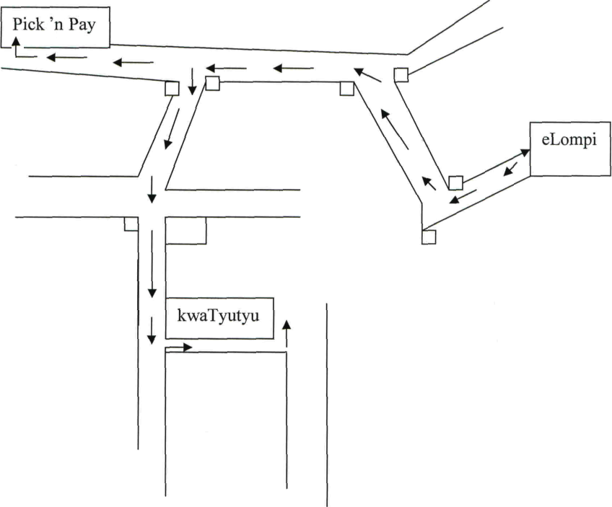 |  |  | [20]
 |  | AMANQAKU EWONKE: | 100

