Province of the
EASTERN CAPE
EDUCATION

Steve Vukile Tshwete Education Complex • Zone 6 Zwelitsha 5608 • Private Bag X0032 • Bhisho 5605
REPUBLIC OF SOUTH AFRICA

CHIEF DIRECTORATE – CURRICULUM MANAGEMENT

INKQUBO YOKUNCEDISA ABAFUNDI BEBANGA LE-12

ISIXHOBO SOKUFUNDA ESILUNGISELELWE UHLAZIYO NOKUNCEDISA:
IMIBUZO NEEMPENDULO

ISIFUNDO: ISIXHOSA ULWIMI LOKUQALA OLONGEZELELWEYO – ISIGABA SOKUQALA

EYESILIMELA 2009

ESI SIXHOBO SINAMAPHEPHA ALI-12.

QAPHELA: Eli phepha lahlulwe langamacandelo amathathu ami ngolu hlobo:
ICANDELO A – IZICATSHULWA
ICANDELO B – ISISHWANKATHELO
ICANDELO C – UKUSETYENZISWA KOLWIMI
IMIYALELO:
1. | Phendula YONKE imibuzo ngesiXhosa.
2. | Qala iCandelo ngalinye ephepheni elitsha uze ukrwele umgca emva kweCandelo ngalinye.
3. | Shiya umgca phakathi kweempendulo zakho.
4. | Bhala ngokucocekileyo nangokucacileyo.
5. | Nika ingqalelo eyodwa kuPELO nendlela owakha ngayo IZIVAKALISI zakho.

ICANDELO A

UMBUZO 1

ISICATSHULWA 1
Funda esi sicatshulwa singezantsi uze uphendule imibuzo elandelayo
 |  | Urhulumente weDemokhrasi
Urhulumente wedemokhrasi awungekhe uhambe umbuza kuba uneempawu zakhe ezibonakalayo ekukho phakathi kwazo ezi:
1. | Unyulo olukhululekileyo: Oku kuthetha ukuba abantu banikwa ithuba lokuzikhethela umntu abathanda ukukhokelwa nguye, badandalazise nezimvo zabo bathethe phandle bengabambanga mizimba besoyika ukubanjwa. Konyulwa rhoqo, umzekelo, emva kweminyaka emihlanu ukuze kuqinisekiswe ukuba ngenene urhulumente uphatha eqwalasele iimfuno zoluntu. Oku kwenza ukuba abaphathi bakhwentshele imisila besazi ukuba baza kukhiqwa eluvotweni ukuba abayenzi into enqwenelwa ngabantu. Koorhulumente kukho urhulumente weziphaluka norhulumente kazwelonke. Nokuba lunyulo olukhululekileyo na akuthethwa ukuthi yonke into iyekwa nje. Awumelanga ukuba uvote uneminyaka engaphantsi kweminyaka elishumi elinesibhozo. Kufuneka ube nencwadi yesazisi eyamkelekileyo. Kufuneka ube ngummi welo lizwe ulivotelayo. Ukuze uqonde ukuba lunyulo olukhululekileyo uvotela ekhusini ukuze uvotele loo mntu umthandayo ungakhange unyanzelwe ungakhange unyotywe. Kaloku okunyobayo uzidla ixesha kuba ungasithatha eso sinyobo sakhe kodwa ungavoteli yena phaya ekhusini kuba akakuboni.Unako ukuthi umvotele ngoku ungamvotelanga.
2. | Ulawulo loninzi: Naziphi na izigqibo afikelela kuzo urhulumente iba zezo bezigqitywa luninzi lwabantu. Abameli banxibelelana nabantu bonke beve izimvo zabo ngomba othile batsho bathathe izigqibo zoninzi lwabantu. Imigaqo nemithetho yelizwe isetyenziswa xa ivunywe ngabantu abaninzi.
3. | Urhulumente womgaqo-siseko: Umgaqo-siseko ngoyena ndoqo kurhulumente wedemokhrasi. Kaloku umgaqo-siseko uchaza yonke imithetho yelizwe ekhusela wonke umntu. Wonke umntu uxelelwa ilungelo lakhe kumgaqo-siseko. Wonke ke umntu uyaxhamla kula malungelo. Ibanjwa, umsebenzi, umntwana, ummi, umphathi, nazo zonke iindidi zabantu zixhamla amalungelo azo abhaliweyo avunyiweyo kumgaqo-siseko.
4. | Imibutho yezopolitiko: Yonke imibutho yezopolitiko ithatha inxaxheba ekulawuleni ilizwe. Kubakho abameli babantu abamele imibutho yabo phaya ePalamente. Aba bameli banelungelo lokuphikisa imithetho esekwayo xa bebona ukuba ayihambisani neemfuno zabantu babo ababameleyo.

5. | Imibutho yangasese: Ikhona imibutho engalawulwa ngurhulumente. Amaphephandaba, iimagazini, azilawulwa ngurhulumente. Umanyano lwabasebenzi borhwebo (trade union), alulawulwa ngurhulumente.
 | Iphepha 1 Uvimba 8
1.1 | Chaza iimpawu zorhulumente wedemokhrasi zibe NTLANU. |  | (5)
1.2 | Nika intsingiselo yezi ziqwengana:
 | (a) | Bengabambanga mzimba
 | (b) | Bekhwetshele imisila
 | (c) | Baza kukhiqwa
 | (d) | Uvotela ekhusini
 | (e) | Ube ngummi welo lizwe | (5)
1.3 | Yintoni injongo yokuba kubanjwe unyulo rhoqo emva kweminyaka emihlanu? |  | (2)
1.4 | Chaza iindidi zoorhulumente ezithi zifumaneke ngokwalapha kwisicatshulwa. |  | (2)
1.5 | Imigaqo nemithetho yelizwe iphunyezwa xa kutheni? |  | (1)
1.6 | Umgaqo-siseko ubaluleke ngantoni elizweni? |  | (1)
1.7 | Ngubani onoxanduva lokuphikisa umthetho ongahambiselani  neemfuno zabantu? |  | (1)
1.8 | Chaza imibutho emiBINI engalawulwa ngurhulumente. |  | (2)
1.9 | Wena njengommi woMzantsi Afrika unoxanduva lokwenza ntoni  elizweni lakho? |  | (1)
 |  |  | [20]

UMBUZO 2
ISICATSHULWA 2
 | Ingaba yindlela yokuziphatha le?
Kuthe kusakufunyanwa inkululeko eMzantsi Afrika ngowe -1994, satsho sabuya isidima somntu oMnyama watsho naye wahlonitshwa. Noxa kunjalo, zisekho izaphuselana ezifane ziphukaneke kuba kaloku le nto isisiqhelo siyayoyisa ingqondo. Basathe gqolo abaMhlophe besenza amayelenqe okubhukuqa lo mbuso uze nenkululeko enconywa lihlabathi liphela. Kaloku eyethu inkululeko sayifumana ngaphandle kwezigalo. Mihla nezolo kubhaqwa izixhobo ezingene ngondlela mnyama kweli ngeenjongo zokubhukuqa lo mbuso.

Baphi oSteve Biko, oChris Hani amadela kufa ayezabalazela le nkululeko. Kungoku nje kuliwa idabi amadlagusha athi unotshe, soze liphuncuke nakuthi eli thambo siliqhelile nje. Kusezikolweni abantwana babaNtsundu balwa nabaMhlophe. Kanti uxolo lwakude lufike nini? Phofu nakwabaNtsundu uxolo alukho. Kusemisebenzini abaphezulu nabasezihlalweni baqashana bodwa okanye baqashe abantwana babo nabezihlobo nezalamane zabo. Babekwa ezikhundleni eziphezulu njengamagosa aphezulu, batsho ukuhlisa imali ngemilenze. Bambi bakhwela ezinamavili emqolo, bangosomashishini abaphezulu, konke oko kuze ngomgunyathi.

Uthi yiyo yona le yokungabethwa kwabantwana ngabazali nasezikolweni bonile? Kungoko kuzele ziinjubaqa, abanye behlala emaphayiphini. Bambi bafuduka ezilalini baya kuhlala ezidolophini, phofu ematyotyombeni, bejonge ukuxhamla kwezi zindlu zakhiwe mahala nguRhulumente. Abantwana abahambi sikolo, batshaya intsangu, babanzima, banxile bekhuthuza ngokunjalo. Luphi ke ulonwabo lwale nkululeko xa kunjalo? Ikwangaba baMnyama abayimoshayo yonke le nquleqhu ize nenkululeko ngenxa yokungakwazi ukuziphatha. Ungakholwa ukuba nabaMhlophe behla benyuka kula matyotyombe bethengisa iziyobisi. Kuyacaca ukuba kuphilwa ngamntu. Noxa kunjalo, sithi yibambeni makhaba aNtsundu kode kulunge noba kunini na.

(Yonwabela isiXhosa 10 Iphepha 97-98)
2.1 | Ingaba ikhona into ezinxulumene ngayo ezi zicatshulwa zibini? Chaza | (2)
2.2 | Ingaba yintoni unobangela wokusuka kwabantu ezilalini beze ezidolophini? | (2)
2.3 | Ingaba imeko yezopolitiko eMzantsi Afrika iyalinika na ithemba  njengoko kubhengezwa koonomathotholo nokoomabonakude kweli xesha lezonyulo? Xhasa impendulo yakho. | (2)
2.4 | Inkululeko yoMzantsi Afrika ize neziphumo ezinjani xa ujonge imeko  yezopolitiko kweli lizwe laseMzantsi Afrika. | (2)

2.5 | UChris Hani wayemele eliphi iqela kumaqela ezopolitiko kula alandelayo?
 | i) | Saccawu
 | ii) | Cosatu
 | iii) | AmaKomanisi |  | (1)
2.6 | Nika isithetha ntonye seli gama: amadlagusha |  |  | (1)
 |  |  |  | [10]
 |  | AMANQAKU ECANDELO A: |  | 30
ICANDELO B
UMBUZO 3
Funda esi sicatshulwa silandelayo uze usishwankathele ngamagama amalunga nama-60 − 70: Zama ukushwankathela ngamazwi akho.
1. | Shwankathela ngezivakalisi ezipheleleyo. |  |  | (2)
2. | Sebenzisa awakho amazwi ngokusemxholweni. |  |  | (2)
3. | Shwankathela ungadluli kumagama angama-60. |  |  | (2)
4. | Bhala inani lamagama owasebenzisileyo ngezantsi kwesishwankathelo |  |  | (2)
5. | Umsebenzi wakho mawucoceke. |  |  | (2)
 | Qaphela uza kohlwaywa xa ungayenzanga le miyalelo ingasentla.
Ukhuphiswano

Apha ekuhlaleni sikhuphisana ngeendlela ngeendlela. Siyakhuphisana kwezemidlalo efana nebhola ekhatywayo, eyombhoxo, intenetya iqakamba, ihoki, neminye. Kuninzi lwale midlalo sikhuphisana singamaqela okanye sizimele. Xa kudlalwa intenetya akho amaxesha okuba indoda ijongane ekolweni nenye okanye intokazi izive amandla kwenye. Kukhuphiswano lweendadi elowo uyazimela, mhlawumbi amele ilizwe lakhe. Kumaxesha amaninzi kukhuphisana isizwe nesinye njengakwimidlalo yebhola.

Ukhuphiswano lomculo weekwayala luyinto eqhelekileyo, kanti namaqela angezokwayala ayakhuphisana. Abafundi bezenzululwazi nabezibalo banokhuphiswano loyena mfundi ugqwesileyo minyaka le, athi lowo uphumeleleyo awele aye phesheya kweelwandle aye kuphuhlisa ulwazi kweso sifundo agqwese kuso. Abafundi bakhuphisana nangokubhala esona sincoko siyincamisa-mxhelo. Nabachwelayo abafundi bayakhuphisana ngezinto abazichwelileyo, ze lowo mfundi uchwele eyona nto intle kuzo zonke kuxhwithwane ngaloo nto ibe ngulowo usozimali afune ukuzithengela yona.

Umbuzo ngowokuba kutheni ke abantu bangasebenzisani nje basuke bakhuphisane? Zininzi izizathu ezibangela ukuba abantu bakhuphisane. Sikhuphisana xa sifuna ukubona ukuba ngubani na ogqwesayo okanye leliphi ilizwe eligqwesayo kwinto ethile. Iintombi ziyakhuphisana ukubona ukuba yeyiphi eyona ntombi intle kunazo zonke ezelo zwe layo okanye entle emhlabeni wonke. Lowo uphumeleleyo wotha kudumo lwaloo mpumelelo yakhe. Kanti ke imali eza nempumelelo yengathethekiyo. Iimbethi-manqindi zihlawulwa izigidi ngezigidi ngokuphumelela. Kanti nongaphumelelanga kulo mdlalo uzuza isitywentywe. Bakho ke nabantu abakhuphisana nje kuba befuna ukuva mnandi ngaphakathi kubo egileni. Xa ephumelele kugqityiwe nokuba akafumananga nto iyintlawulo.

Lulungile ukhuphiswano, kanti ngamanye amaxesha alulunganga. Lulungile xa luphucula intlalo yabantu. Lulungile xa kuphuhliswa umgangatho waloo nto kukhutshiswana ngayo. Lulungile xa luphuhlisa iziphiwo ngeziphiwo zabantu nobuchule babo. Abanye abantu abaze bayazi into abagqwesa kuyo de bakhuphisane nabanye abantu. Lulungile xa kukhuphisana oomama ngezitiya zabo zemifuno kuba kutyiwa kwezi zitiya, zityebe iintsapho zabo zibe ziziputsu, kuphele uchuku nentlebendwane, iibhanki zimimitheke.

(IsiXhosa 2005 Iphepha 93-94)
 | (Ukhanyo Ibanga 11 iphepha 32) | [10]
 | AMANQAKU ECANDELO B: | 10

ICANDELO C

UMBUZO 4
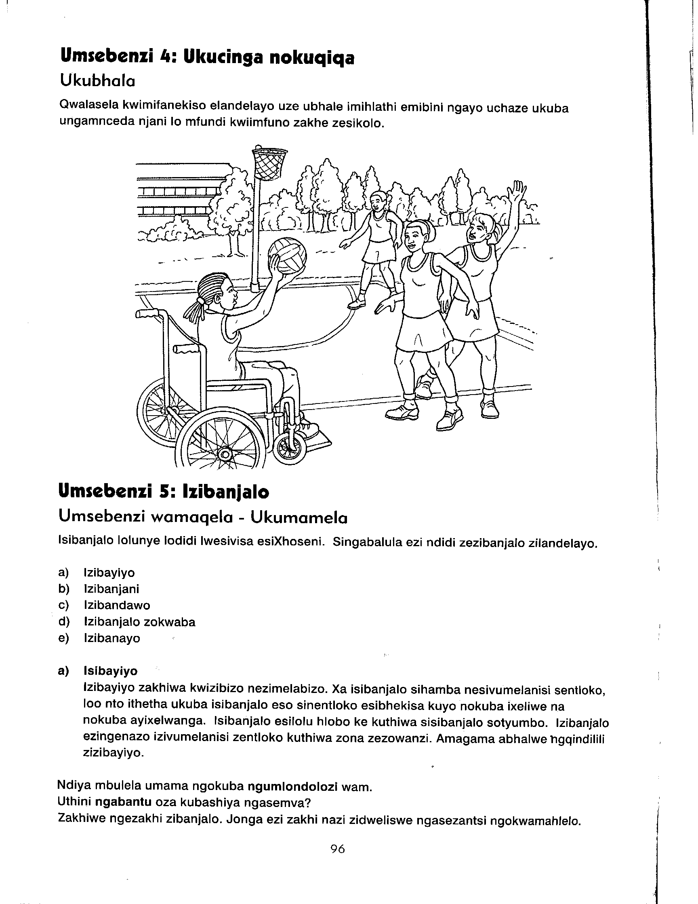
Jongisisa lo mfanekiso ulandelayo uze uphendule imibuzo emalunga nawo.
 |  | (Iphepha 96 My Clever Isixhosa Gr 9)
4.1 | Nika isalathandawo esichaza indawo ekudlalelwa kuyo. |  | (1)
4.2 | Leliphi igama elichanekileyo esinokulisebenzisa ukuchaza le ntombazana  ihleli esitulweni esinamavili? |  | (1)
4.3 | Chaza izenzo zibe ziBINI ezinokuba zenziwa yintombi ephakathi kula mathathu amileyo. |  | (2)
 |  |  | [4]

UMBUZO 5
Funda olu ngeniso lwedayari lungezantsi uze ulungise iziphene ezifumaneka kulo. Bhala izilungiso ezo kuphela.
20 kuJuni 2009 ngolwesihlanu: Umama usathetha ngebhethdeyi yakhe
nanamhla oku. Kodwa bekumhandi nyani.
21 kuJuni 2009 ngoMgqibelo: Andonwabe ngako kuyahambwa ngomso
kuyiwa eRhawutini, ngumdlalo webhola
ekhatywayo.
22 kuJuni 2009 ngeCawa: unodwe uthi uzakuyikhaba ilayiti ekhe
yamgezela yena. Bekugcwele kwelo holo
kakhulu kungekho nendawo enokuhlala
nempukane le!
23 kuJuni 2009 ngoMvulo: Lemini ishushu kakulu. Ndicimfanuba ndiye
edamini lokuqubha idayari yam mayife
namthanyana okwangoku. Mandiye.
24 kuJuni 2009 ngoLwesibini: Ongezanga, uphoswe yidiski yokwenyani.
Ngomso sesigoduka, kowu andisadikwe nje
[10]

UMBUZO 6
Jonga le khathuni ingezantsi uze uphendule imibuzo elandelayo.
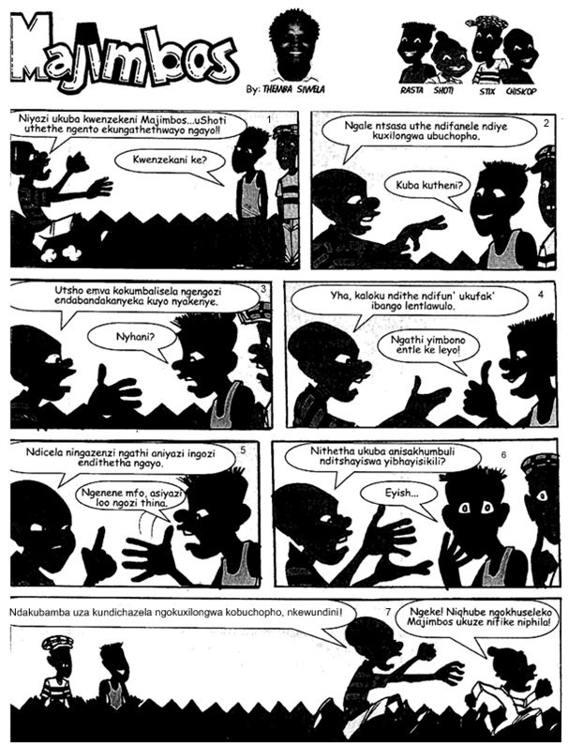
 |  | [IBona Xhosa –May 2008]
6.1 | Bhala imo epheleleyo yesi senzi sikwisikwere soku-1: Kwenzekani |  | (1)
6.2 | Nika imizekelo emiTHATHU ebonisa iimeko ezahlukeneyo zokushiywa  kweceba, uze uchaze imbangi yokuba lishiywe. |  | (3)
6.3 | Cacisa ngomsebenzi wesimeli nobumba esisetyenziswe kwisikwere-4. |  | (1)

6.4 | Igama u- Eyish....okwisikwere-6 unika yiphi intsingiselo? |  | (1)
6.5 | Nika isichasi segama u-entle okwisikwere-4. |  | (1)
6.6 | Nika iintsingiselo zala magama alandelayo:
 | - Endabandakanyeka – isikwere-3
 | - Ibango – isikwere-4 |  | (2)
6.7 | Isithethantonye sika – soze ngu... (Gqibezela). |  | (1)
6.8 | Inkangeleko yaba bafo bakwisikwere sesibini injani? “ Kuba kutheni?” Nika isizathu sempendulo yakho. |  | (2)
6.9 | Nika igama elinye lale nkcazelo ilandelayo:
 | - Umntu okrelekrele ngendalo kuthiwa yi ...
 | - Umntu oqeshelwe ukubamba izaphuli mthetho li ... |  | (2)
6.10 | Yintoni ebangele ukuba abe uChiskop uza kuya kuxilongwa ingqondo? |  | (1)
6.11 | Leliphi eli Sebe kwezolawulo likhuthaza la mazwi okugqibela kaShoti afumaneka kwisikwere sokugqibela kule khathuni? |  | (1)
 |  |  | [16]

UMBUZO 7
Yakha isaci okanye iqhalo ngale mifanekiso ingezantsi.

7.1 7.2 7.3
[3]

UMBUZO 8
Fakela isihlanganisi esifanelekileyo kwezi zikhewu zingezantsi. Bhala isihlanganisi eso kuphela.
Ndiyabona ... ufuna ukucengwa ngeencwadi zakho, ... ke mna bendikunceda...imfundo le yeyakho mntwabantu ayiyoyam. |  |  | [3]
UMBUZO 9
Sebenzisa la magama angezantsi kwizivakalisi eziBINI igama ngalinye ngendlela eya kuthi iphuhlise ukwahluka kweentsingiselo zawo.
9.1 | Ubomi
9.2 | Umnyama (2x2) = |  | [4]
 | AMANQAKU ECANDELO C: |  | 40
 | AMANQAKU EWONKE : |  | 80

