XHOHL

ISEBE LEMFUNDO LEMPUMA KOLONI
EASTERN CAPE EDUCATION DEPARTMENT
OOS-KAAP ONDERWYSDEPARTEMENT

IIMVIWO ZEBANGA LESHUMI ELINANYE
GRADE 11 EXAMINATIONS
GRAAD 11-EKSAMEN

NOVEMBA 2008

ISIXHOSA ULWIMI LWASEKHAYA − IPHEPHA LESITHATHU

IXESHA: 2 ½ iiyure TIME: 2 ½ hours TYD: 2 ½ uur
AMANQAKU: 100 MARKS: 100 PUNTE: 100

Bhala emva ….

Write on the cover of your answer book, after the word “Subject” –

ISIXHOSA ULWIMI LWASEKHAYA − IPHEPHA LESITHATHU

Olu viwo lunamaphepha ali – 10.

IIMIYALELO EYA KUBAFUNDI

- Umviwa kulindeleke ukuba aphendule umbuzo OMNYE kwiCandelo ngalinye.
- Icandelo ngalinye malibhalwe kwiphepha elitsha, uze ukrwele umgca
wakugqiba icandelo elo.
- Bhala cacileyo nacocekileyo, ucwangcise kakuhle umsebenzi wakho.
- Nika ingqalelo eyodwa kupelo lwamagama kunye nolwakhiwo lwezivakalisi.

- UBUDE BEEMPENDULO:

ICANDELO A: ISINCOKO: Bhala isincoko esingama-290-340 amagama.
(Amaphepha amabini ukuya kwamabini anesiqingatha).

ICANDELO B: IMIHLATHANA EMIDE: Bhala ama-100-120 amagama

(Iphepha elinye ukuya kwelinye elinesiqingatha).

ICANDELO C: IMIHLATHANA EMIFUTSHANE: Bhala ama-80-100 amagama. (Iphepha elinye kuphela).

ICANDELO A: IZINCOKO

UMBUZO 1

Khetha isincoko sibe siNYE kwezi zilandelayo. Bhala isincoko esingama
290 - 340 amagama (Amaphepha amabini ukuya kwamabini anesiqingatha).

  - “Ukuba ndandazile,” Thathela kula mazwi ubalise iziganeko ezithe zenza
isithethi sifikelele kuloo mazwi okanye kweso sigqibo. [50]
OKANYE

  - “Umntu yinkosi ukuzazi” Xoxa ngezinto ezilulutho kuwe nezinto ezikwenza
uqaqambe, kunye neziphene okanye ububhetyebhetye onabo,
obungakudobelela ungaphumeleli kwiminqweno yakho. [50]
OKANYE

1.3 Imini yenkqwithelo, isitshi kunye nezandyondyo zemvula. Chaza. [50]

OKANYE

1.4 Thathela kokubona kule mifanekiso ingezantsi ubhale isincoko ubonise
ukulunga nokungalungi kokuba abantu ababhinqileyo babekwe kwinqanaba
elinye nootata emisebenzini, badlale nemidlalo eyayisakuba idlalwa ngamadoda. [50]

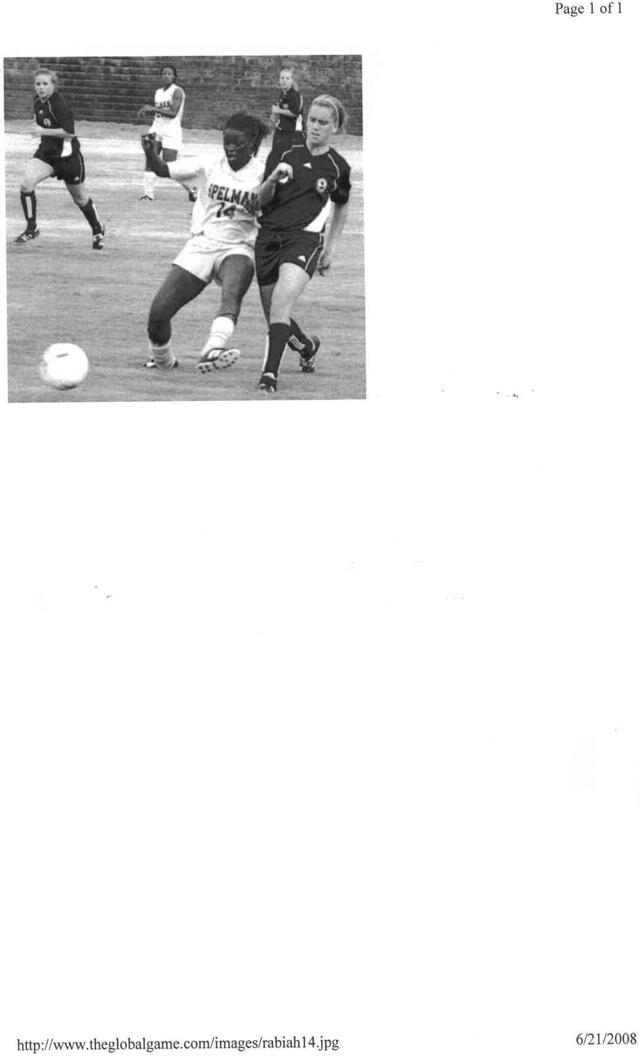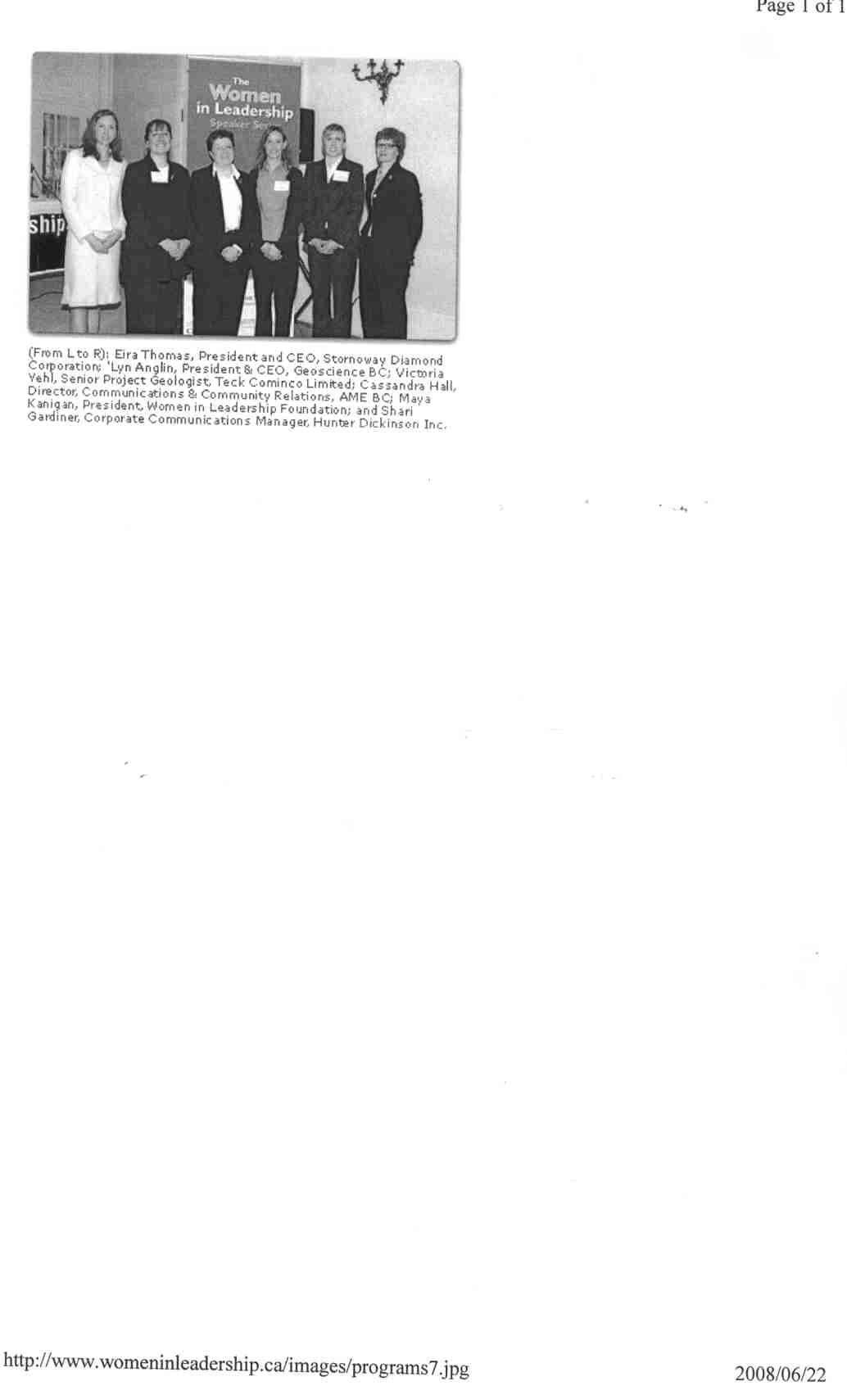
Iqela lebhola ekhatywayo Abasetyhini kwizikhundla zolawulo

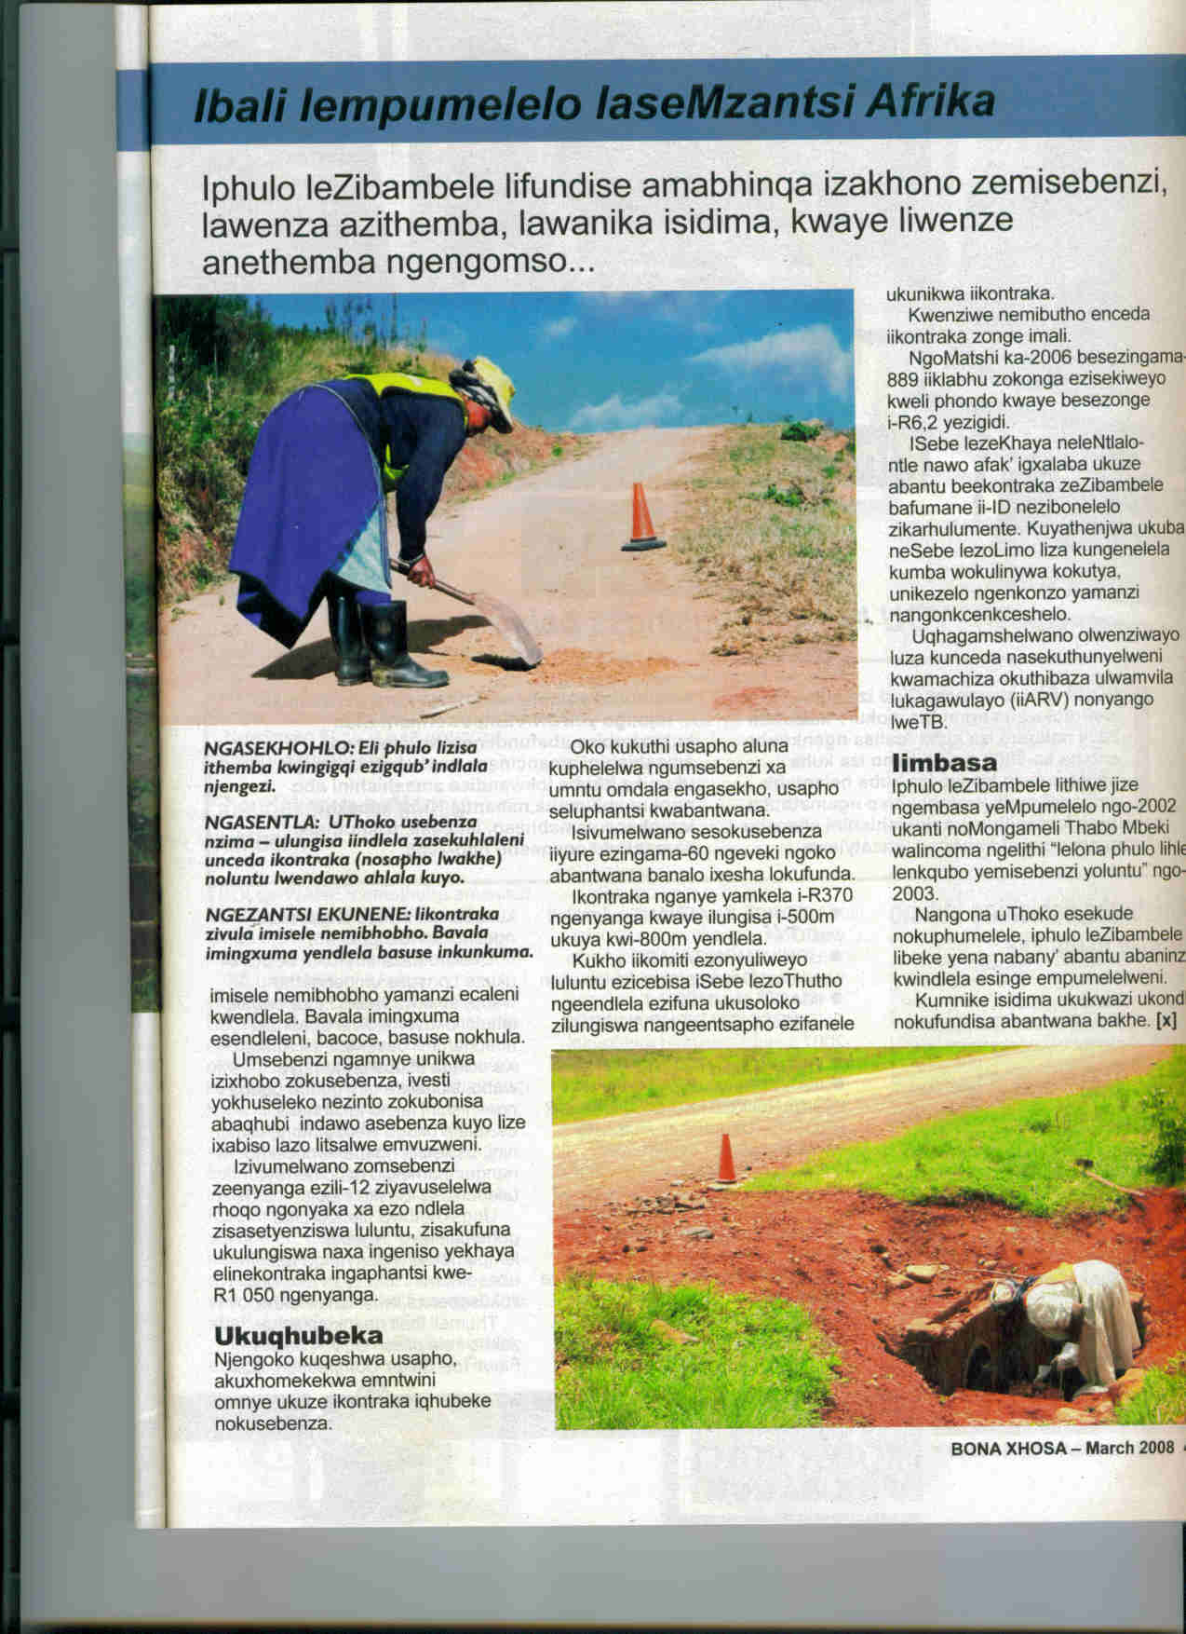
Oomama abasebenza ezindleleni

OKANYE

1.5 Ukuphangela kwabantwana abasebancinane kuxhaphakile kwixesha
esiphila kulo. Kubangelwa yintoni oku? Ungapheliswa njani lo mkhuba? [50]

OKANYE

  - Ukusilela kwabazali ekuqeqesheni abantwana kunganegalelo elikhulu
ekwandiseni izinga lobundlobongela. Uyavumelana nale ngcamango? [50]

EWONKE AMANQAKU ECANDELO A: [50]

ICANDELO B

IMIHLATHANA EMIDE

UMBUZO 2

Khetha umhlathana omde ube MNYE kule ilapha ngezantsi ubhale ngawo.
Ubude mabube ngamagama ali-100 ukuya kuma-120. (Iphepha elinye ukuya
kwelinye elinesiqingatha).

2.1 INGXELO

Kwinyanga ephelileyo uthunywe ngumbutho wolutsha ekuthiwa nguNonophela ojongene nokhuseleko lwendalo kwinkomfa ebikwisithili sakho. Bhala
ingxelo, uphalazele abanye abafundi ngolwazi olufumeneyo. [30]

KANYE

  - ILETA YOBUHLOBO

Ezi ziindawo ozimisele ukuya kuchitha iiholide zikaDisemba kuzo. Bhalela
isihlobo okanye umhlobo wakho osenyongweni ileta ummeme aze
kuchitha nawe ezi ntsuku kwezi ndawo zilandelayo: [30]

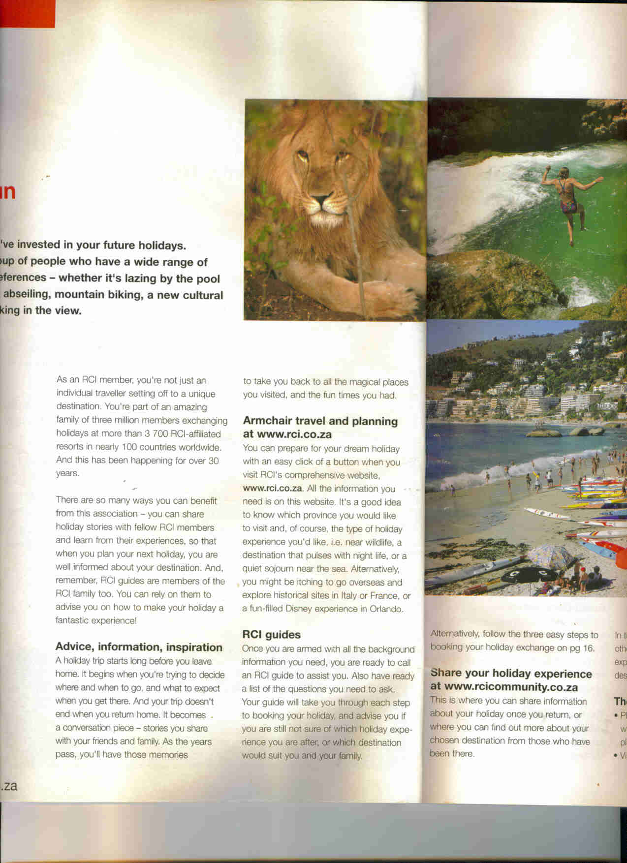
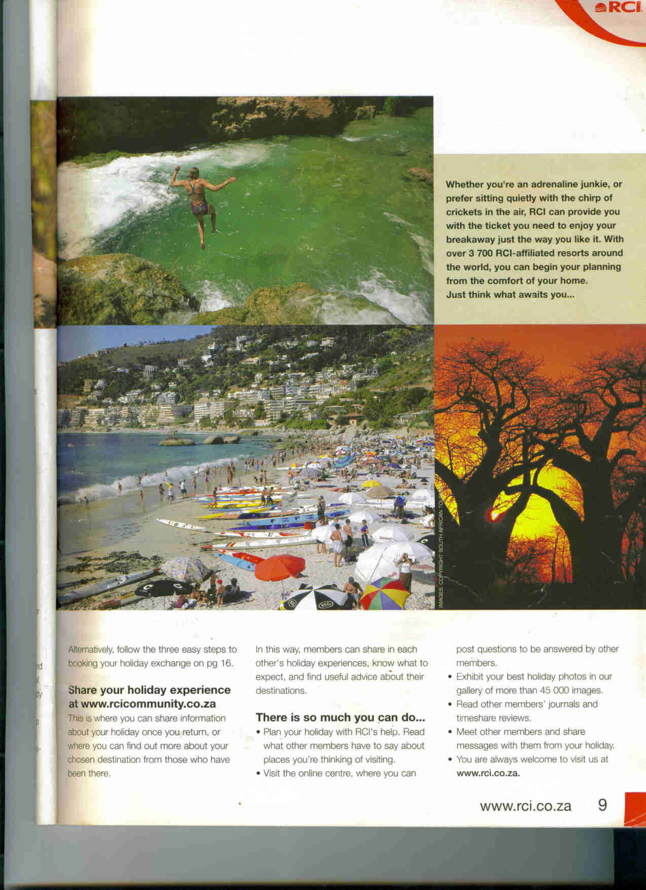

Indawo yogcino lwezilwanyana Elwandle 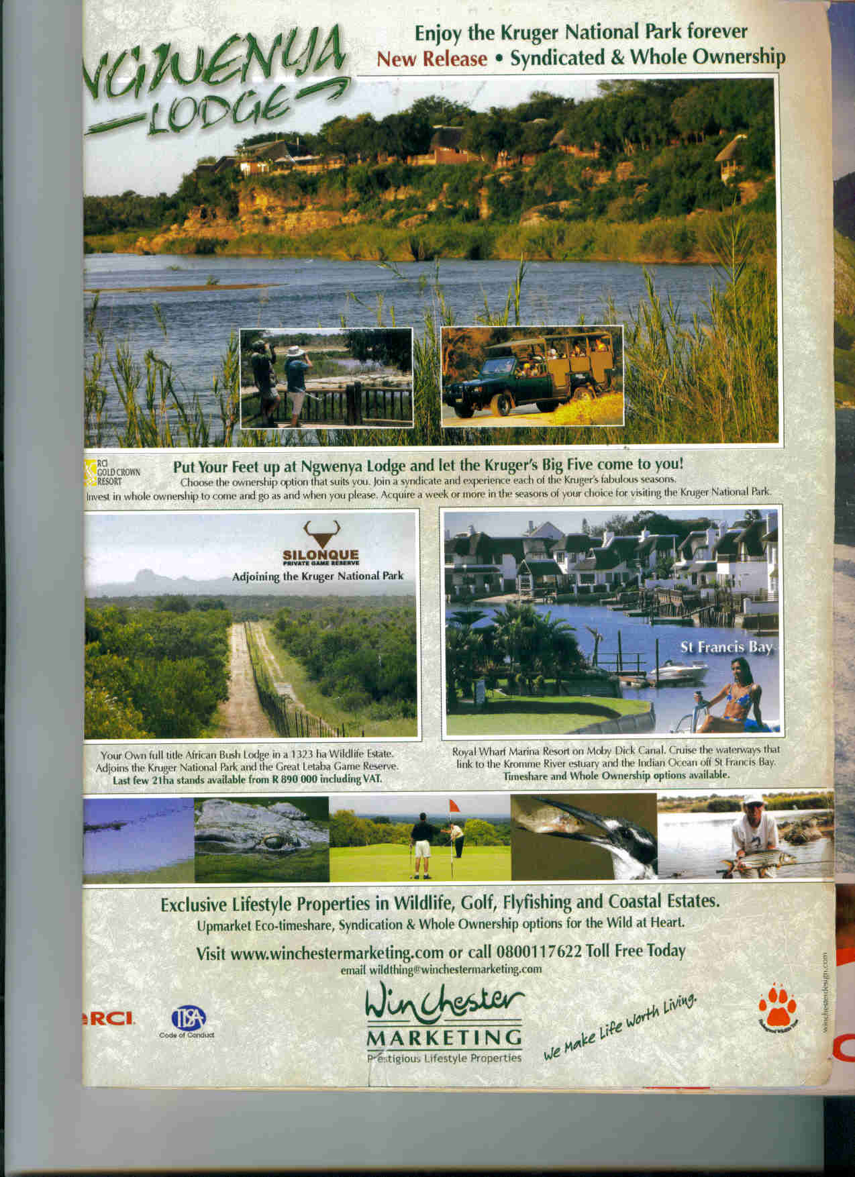
Iindawo zokuhlala ngaselwandle Ulwandle

[R.C.I.Directory of Resorts (2005-2006) page 8,9 and 105 ] .

OKANYE

2.3 ILETA EYA KUMHLELI WEPHEPHA-NDABA

Ngempelaveki edlulileyo ububukele umbono ohlasimlisa umzimba apho
abahlali babambe isela balibethela ibhokisi. Bhala ileta eya kumhleli
wephepha-ndaba, “IMVO ZOLUTSHA” uphalaze imbilini yakho ngalo
mkhuba, ulumkise noluntu malunga nokuthathela umthetho ezandleni. [30]

OKANYE

2.4 INGXOXO YABABINI

Ingxoxo ishushu phakathi komzali nomntwana, bebonisana ngekhondo
amakalilandele ukuze abe nekamva eliqaqambileyo. [30]
EWONKE AMANQAKU ECANDELO B: [30]

ICANDELO C

IMIHLATHANA EMIFUTSHANE

UMBUZO 3

Bhala umhlathana ube MNYE kweli Candelo.
Ubude bawo mabube ngamagama ali-100 ukuya kwali-120. (Iphepha elinye kuphela)
Qala kwiphepha elitsha.

3.1 IDAYARI

Uza kuqala ukubhala iimviwo zakho zokuphela konyaka ngomhla we-11 ukuya
kutsho ngomhla wama-20 kwaye ubuqhube kakubi kakhulu kwiimviwo zikaSeptemba.
Yenza isicwangciso sosuku ngalunye esiza kubonisa ukuba uza kwenza njani ukuleqa
ukuze kolu uviwo ungaphindi ubethakale. Faka kwidayari yakho zonke izinto ocinga
ukuba ungazenza ukuphuma kwakho esikolweni kusuku ngalunye kwezi zixeliweyo
ngasentla ukuphucula iziphumo zakho kwezi mviwo. [20]

OKANYE

3.2 UKUZALISWA KWEFOMU

Nasi isithuba somsebenzi sibhengezwe apha ngezantsi. Zalisa ifomu

oyinikiweyo ezantsi kwesi sibhengezo ngeenjongo zokucela lo msebenzi.

ISEBE LEZEMPILO

Izikhundla zingamashumi amabini!

Kwisibhedlela iNompumelelo eNgqushwa (inombolo yesikhundla 351).

Intlawulo:R69 000 ngonyaka.

Iimfuneko:Ibanga le-10 nele-11.

Umsebenzi oza kuwenza :
- Ukuba ngumongikazi /umongi oncedisayo.

- Ukwenza ingxelo ezibhaliweyo nezomlomo ngezigulana.

- Ukutolikela oogqirha nezigulana.

- Ubhaliso lwezigulana kwirejista.

Izinto ezinokukuthethelela.

- Ukukwazi ukuthetha nabantu beendidi ngeendidi.

- Ulwazi lwekhompyutha.

Imibuzo: Ingabhekiswa kuNksz. S.Hlalaphantsi.

Umnxeba :043 7221561

ISICELO SOMSEBENZI

 | A. ISITHUBA ESAZISIWEYO
 | Isithuba osenzela isicelo njengoko sazisiwe |  |  |  |  | Isebe esikulo isithuba
 | Inombolo enikwe esi sikhundla kwisibhengezo |  |  |  |  | Ukuba uyaqeshwa unganika ithuba elingakanani ukuba uqalise kulo msebenzi?
 | - IINKCUKACHA NGAWE
 | Ifani
 | Amagama akho
 | Umhla wokuzalwa
 | Iinombolo zesazisi
 | Uhlanga
 | Isini |  |  |  |  |  |  |  |  | Ibhinqa |  |  | Indoda
 | Umceli mngeni |  |  |  |  |  |  |  |  | EWE |  |  | HAYI
 | Ungummi waseMzantsi Afrika |  |  |  |  |  |  |  |  | EWE |  |  | HAYI
 | Ukuba awungommi ungowaliphi ilizwe?
 | Unawo amaphepha mvume okusebenza kweli lizwe? |  |  |  |  |  |  |  |  | EWE |  |  | HAYI
 | Wakha wabanjwa ngaphambili? |  |  |  |  |  |  |  |  | EWE |  |  | HAYI
 | C. IDILESI YOKUPOSA
 | Ulwimi lokunxibelelana nawe olukhethayo
 | Iinombolo zomnxeba ngexesha lomsebenzi.
 | Indlela yonxibelelwano oyikhethayo |  |  |  | Iposi |  |  | E-meyile |  |  | Ifekisi
 | Inombolo emayisetyenziswe kuhlobo olukhethe ngentla
 | D. UBUCHULE KWIILWIMI- XELA: Kakuhle/ Ngokufanelekileyo/ Buthathaka
 |  | Iilwimi
 |  | ISIXHOSA | ISINGESI |  |  |  | ISIZULU |  |  |  |  | ISISUTHU
 | Thetha
 | Funda
 | Bhala

E. IZIQINISEKISO ZEMFUNDO
Igama lesikolo ofunde kuso | Eyona mfundo iphakamileyo | Unyaka oyifumene ngawo
Imfundo ephakamileyo
Igama leziko lemfundo | Iziqinisekiso zemfundo | Unyaka oyifumene ngayo
Osayifundayo(imfundo neziko ofunda kulo)

F. IINKCUKACHA ZOKUSEBENZA KWIMINYAKA ENGAPHAMBILI
Umqeshi | Isikhundla | Ukusuka |  | Ukuya |  |  | Isizathu sokuyeka
Umqeshi | Isikhundla | Nyanga | Nyaka | Nyanga |  | Nyaka
Ingaba sikhona isithintelo osaziyo ngokwasemthethweni esinokukubangela okokuba ungabuyi uqeshwe kumasebe kaRhulumente? |  |  |  |  |  |  | EWE | HAYI
Ukuba impendulo ngu-”EWE” ngentla, xela eli Sebe.

G. ABANTU ABANOKUSAZISA NGAWE
Igama | Ubuzalwane nawe | Iinombolo abafumaneka kuzo

ISIFUNGO /ISIQINISEKISO
Ndiyaqinisekisa ukuba lonke ulwazi endilunike apha luyinyani.
Intsayino-gama: | Umhla:

OKANYE

  - IFLAYA

Niziqalele ubuxhofuxhofana beprojekthi eza kugcina ulutsha luxakekile
ngoDisemba kwingingqi yakho. Yila iflaya emema uluntu olunezi ngxaki
zibalwe ngezantsi luzizise kuni:

- Iiplastiki ezindala nezingcolisayo.
- Amaphepha-ndaba amadala axakileyo kumakhaya ngamakhaya.
- Iintsimbi ezindala ezingcolisa okusingqongileyo.
- Amavili amadala eemoto kunye neengcingo ezindala.

Banike ezi ngcombolo abantu kule flaya:

Igama lomntu ekunokudityanwa naye.
Iinombolo zomnxeba.
Idilesi echaza indawo abanokuzisa kuyo ezi zinto zibaxakileyo. [20]

EWONKE AMANQAKU ECANDELO C: [20]

EWONKE AMANQAKU: 100

